Dear Professor Parker,

Contained within this document you will find my report for the High Performance Compute Cluster Senior Project. The scope of this report is to demonstrate the completion of and functional testing of the project. The status of the project is complete, if you have any questions please contact me at [stourt01@pfw.edu](mailto:stourt01@pfw.edu).

Enclosure: Final Report

High Performance Compute Cluster

Technical Manual

**4/27/20**

**Rory Stouder**

Michelle Parker

Submitted to:

Michelle Parker ITC481

Department of Computer, Electrical, and Information Technology

College of Engineering, Technology, and Computer Science

Purdue University Fort Wayne

# I. Abstract

Using at least two, to-be recycled computers, a managed gigabit switch, and ROCKS cluster centOS 7.0 operating system you can create your own supercomputer in your house. By clustering more than one computer into a single computing unit you are able to perform massive calculations faster then with a stand-alone desktop computer. For our high performance compute cluster we used four computers, while you can add as many computers to the cluster as your subnet will handle, we only had access to four computers. The applications of this are mainly used in data driven research, or computational nightmares, such as weather forecasting, or solar system modeling, for rocket launches or accurate satellite placement. ROCKS clusters can also be used for Genomics research, computational chemistry, and particle collision modeling from data gathered from a particle accelerator. The plan for testing my high performance compute cluster was to calculate Pi out to 1 million digits and save it as a text file.

**Keywords**

Pi, ROCKS, Compute, gigabit switch, Sun Grid Engine, subnet, CPU

**Table Of Contents**

**I. Abstract** **3**

**II. Executive Summary** **8**

**III. Project Introduction** **11**

Problem Statement 11

Topics to Investigate 11

Audience 12

Background 12

Criteria 12

Methods and Procedure 13

Qualifications and Resources 15

Work Schedule 15

Budget 16

Design Process 18

System Scope 18

Hardware & software 18

Hardware used 19

Software used 21

**IV. Usability Test** **22**

Introduction 22

Executive Summary 23

Methodology 24

Sessions 24

Participants 25

Roles 26

Evaluation Tasks/Scenarios 26

**Results** **26**

Task Completion Success Rate 26

Task Ratings 27

Following along with the information in the steps 27

Keep track of progress 28

Accurately complete all steps 28

Time on Task 29

Errors 29

**Overall metrics** **30**

Overall Ratings 30

Likes, Dislikes, Participant Recommendations 32

Like Most 32

Liked Least 32

Recommendations for Improvement 32

**V. Project Management** **33**

Schedule and Time Management 33

Research 33

Primary Planning 33

Hardware 33

Software 33

Primary Project Construction 33

Documentation 34

Resource and Cost Management 34

Quality Management 35

Risk Management 35

**VI. Issue Log & Lessons Learned** **36**

Issue Log 36

Lessons Learned 37

**VII. Installation Instructions** **38**

Gather Computer Hardware. 38

Gather software for Installation. 38

Installation of Virtual Environment 39

Frame Construction and Computer Hardware Setup. 43

Setting up Network VLAN 44

Flashing the ROCKS kernel onto USB drive. 46

Installing ROCKS on Frontend Node. 46

Install ROCKS on the Compute node. 52

Programming Pi Calculation 55

**VIII. Conclusion** **59**

**IX. References** **60**

**X. Appendices** **62**

Project Status Reports. 62

Project Charter 94

Project Goals 94

Deliverables 94

Scope Definition 94

Project Milestones 95

Assumptions, Constraints, and Dependencies 95

Risks 96

Budget 96

Project Organizational Structure 97

Project Authorization 97

Computer Frame Drawing 98

# 

# II. Executive Summary

High-Performance Computing, or HPC, is the application of "supercomputers" to computational problems that are either too large for standard computers or would take too long. A desktop computer generally has a single processing chip, commonly called a Central Processing Unit (CPU). By networking each desktop computer and linking the Linux Operating System (linux OS) together you are able to effectively build a computer that contains several CPUs as well as utilizing each desktop’s Random Access Memory (RAM).

Programs for High-Performance Compute systems must be split up into many smaller "jobs" called threads, corresponding to each core. To piece the larger program together, the cores must be able communicate with each other efficiently, and the system as a whole must be organized well. Programs on High-Performance Compute systems create a vast amount of data, which can be very difficult for standard file systems and storage hardware to deal with. Standard file systems, or those defined for personal use, might have an upper limit on file size, number of files, or total storage. High-Performance Compute file systems must be able to grow to contain and quickly transfer large amounts of data via RAM. In addition to data in use, researchers often keep previous data for comparison or as a starting point for future projects.

The purpose of having an installation and operational manual is to train new people in the use of the device described. Most often the use of an installation and operational manual is to onboard someone to the use of the new device. This onboarding would also include the installation of any software or hardware needed to get the device functioning.

Another purpose is to save time, as writing knowledge down allows for the spreading of that knowledge at a rate faster than one person vocally orateing knowledge. It also saves time by providing a reference to return to, and freshen up on concepts not currently understood. This in turn makes the knowledge scalable, in that many people can absorb the same information at the same time on different sides of the world, through posting online.

Further purposes to compile an installation and operational manual for a High-Performance Compute cluster built from recycled computer equipment, is to reduce failure. By giving a set of instructions one person can follow along and reproduce the installation and operation of a high performance compute cluster without making the mistakes made when producing the prototype.

**Keywords**

High-Performance Computing, CPU, RAM, Linux

# III. Project Introduction

## Problem Statement

For my Senior project, of building a High-Performance Compute cluster from recycled computer parts, there are a set of instructions on how to install and configure the compute cluster, but it lacks some of the preparatory work needed to successfully install the Cluster OS. There is also no user manual to help a novice Linux user to startup and perform compute actions on the High-Performance Compute cluster. Without a set of instructions and a user manual, most people would not be able to reproduce a High-Performance Compute cluster with the same accuracy. The process takes many steps repeated on each computer throughout the cluster, they must be followed exactly to accomplish the goal of building a High-Performance Compute cluster. I will attempt to bring the process of building and managing a High-Performance Compute cluster to a level of understanding that anyone with minimal computer skills can accomplish.

## Topics to Investigate

Some of the topics to investigate would be the product manuals of all of the system hardware used in construction of the High-Performance Compute cluster. The intended use of the High-Performance Compute cluster, and how other users might utilize the equipment. Another topic would be how the user interface is navigated. There must be installation instructions, a section on troubleshooting and instruction on how to solve those problems, as well as any safety warnings. Lastly and very important would be to research how successful manuals are constructed.

## Audience

The intended audience for the High-Performance Compute cluster operation manual would be the senior design review board including the class professor. The secondary intended audience would be anyone that has a desire to network and share compute power across old unused computer hardware collecting dust. Both audiences will need a basic understanding of computer hardware, software and Linux installation procedures. They will need some basic knowledge of Internet Protocol (IP) addressing and how to set up a Virtual Local Area Network (VLAN) on a managed network switch.

## Background

I chose to build a High Performance Compute cluster because I always wanted to build a supercomputer with more than one CPU, since I was a little kid and my dad brought home a computer magazine that had a CAD capable computer that had two Pentium 133Mhz CPUs on the motherboard.

## Criteria

The criteria for a successful project are two fold. First there must be more than one desktop computer networked together on a seperate VLAN, where these computers are working in concert as one compute unit or a CPU with 12 cores. Second there must be a testing program that shows the functionality of the Clustered CPU cores.

## Methods and Procedure

The method and procedures that are to be employed in compiling a High-Performance Compute cluster operation manual are varied. To start it would be imperative that research and data collection be the first step. The collection of data entails going through the documentation for the Operating System utilized, collecting any information on the software employed to manage the High-Performance Compute cluster. Collection of hardware manuals that are used in the construction of the High-Performance Compute cluster.

The next procedure to utilize is grouping and organizing the data collected in the previous procedure into chucks that are similar and easily digestible. Starting with an outline following the flow of data steps from downloading and installing to basic administration tips and techniques. Grouping should follow the natural progression of the process involved starting from zero day, and moving through to a fully functioning production machine. Organizing the data within each group so that the data is understood and follows the chronological order layed out in the outline worked up at the beginning during the grouping phase.

Next up on the procedure list would be to actually write the technical manual. The method used to write the technical manual would be in the IEEE editorial style. The IEEE editorial style sets out the guideline to format an engineering paper for publication in accepted journals. This style must include certain criteria which are as follows.

* The Paper Title
* Every published paper must contain an Abstract, which by nature shall not contain numbered mathematical equations.
* All papers must contain Index Terms as provided by the authors.
* Nomenclature lists, which includes any symbol definitions.
* Text Section Headings
  + Primary headings - are enumerated by Roman numerals and centered above the text
  + Secondary headings - are enumerated by capital letters followed by periods.
  + Tertiary headings - are enumerated by Arabic numerals followed by parentheses, and indented one tabular space.
  + Quaternary headings - are identical to tertiary headings, except that they are double indented.
  + Reference and Acknowledgment headings - these are never enumerated.
  + Appendix headings - these are a special case. The primary heading(s) in the Appendix are set according to the usual style, there is flexibility in the enumerations
* Acknowledgments
* References
* Biographies

The last procedure would be a proofreading edit of the manual. This is quite possibly the most important part as there are always things that were missed in the initial writing of the manual. The method that I will be using is a two pronged approach, in that I will first proofread the document to make sure that it is saying exactly what I want it to say. Then the next prong would be to have a peer review of the document so that I have both someone that is proofreading the manual for mistakes, and someone that is performing a use case for the document.

## Qualifications and Resources

The main resource used to write the High-Performance Compute Cluster Installation manual would be the Operating System manuals, the hardware manuals, and online Wiki for the Cluster control software used called ROCKS. By using source material, you are assured that the material will suffice, as credible.

Another qualification would be that I am actively building this cluster, so that I have a hands on approach to writing the documentation for the installation and operation manual for my senior project. This hands on approach will give me insight that someone wouldn’t have if they didn’t directly take place in every part of the operation to be described within the High-Performance Compute Cluster installation and operation manual.

Another resource needed would be an internet connection, to both download the software needed, and to test the functionality of the compute cluster.

## Work Schedule

I started this project on January 23th, and it concluded April 26th. My schedule was developed in part due to the fact that I only had one semester to complete the entire project, in a shorter time frame. I determined what tasks were needed to make a successful High performance compute cluster, then gave myself about two weeks per section. This gave me two weekends to work on each section, as I currently have full time employment, with travel involved. This gave me between 16 and 20 hours per week to work on the project. Where I was able to complete each section ahead of schedule this gave me more time to focus on the other classes I was enrolled in. The tasks that went over schedule I ended up getting less sleep those weeks or let it slide into the next tasks time allotment. For the documentation I need much more time to compile as it was the largest part of the entire senior project, then I had planned for.

|  |  |  |  |  |  |
| --- | --- | --- | --- | --- | --- |
| Milestone | Planned | Forecasted | Actual | Status | Hours To Date |
| Project plan | 01/23/20 | 01/23/20 | 01/23/20 | Completed | 3 |
| Project Hardware and software | 01/26/20 | 01/26/20 | 01/25/20 | Completed | 6 |
| Proof of concept in Virtual | 02/06/20 | 02/06/20 | 01/28.20 | Completed | 10 |
| HPC Cluster build and test | 02/23/20 | 02/23/20 | 02/16/20 | Completed | 40 |
| HPC Cluster Production Run | 03/18/20 | 03/18/20 | 03/30/20 | Completed | 50 |
|  |  |  |  |  |  |
| Deliverable | Planned | Forecasted | Actual | Status | Hours To Date |
| HPC Virtual Environment | 02/06/20 | 02/06/20 | 01/28/20 | Completed | 4 days |
| HPC Cluster Build | 02/23/20 | 02/23/20 | 02/16/20 | Completed | 8 days |
| Documentation | 3/18/20 | 3/18/20 | 04/06/20 | Completed | 14 days |
| Project Binder | 4/26/20 | 4/26/20 | 04/26/20 | Completed | 6 days |
| Senior Poster Day Presentation | 4/26/20 | 4/26/20 | 04/26/20 | Completed | 6 days |
|  |  |  |  |  |  |

## Budget

The total cost to build this cluster if not corporate sponsored would have been about $1400.00 if buying the equipment from a second hand source like ebay. Each computer cost about $90.00. The managed switch is about $180. The Dell latitude 5490 was brand new so it ran about $500.00. The APC UPS cost about $90.00 where the Monitor, keyboard, mouse flash drive and cabling all totaled about $180.00

|  |  |  |
| --- | --- | --- |
| Item: | Cost: | Comment: |
| Dell Optiplex 390 (x2) | $0 | Corporate sponsored |
| ASUSPRO Series (x2) | $0 | Corporate sponsored |
| Dell Latitude 5490 | $0 | Corporate sponsored |
| APC UPS | $0 | Corporate sponsored |
| Cisco SG300-52 | $0 | Corporate sponsored |
| Dell 17” Monitor | $0 | Corporate sponsored |
| USB Flash drive | $0 | Already owned |
| Keyboard and mouse | $0 | Corporate sponsored |
| Cat6 Network cabling | $0 | Corporate sponsored |
| Network Card - PCIe RJ45 gigabit | $17.86 | For compute/public network separation |
| 250GB 3D NAND SSD hard drive (x4) | $173.84 | Solid state harddrives |
| Wood | $11.94 | Frame to hold computers |
| Swivel casters (x4) | $18.64 | Easy movement of computer |
| Total | $222.28 | Spent |

## Design Process

I followed the same design laid out in the Rocks cluster wiki, that described the VLAN and computer hardware requirements. I changed out the factory installed hard drives and replaced them with solid state hard drives so that the data transfer rate from each computer would be optimised. Then I wanted a shelf stable cluster, so I designed a wooden frame to hold all the computer parts together. I chose wood for the frame, because I have woodworking tools, and the materials were cheaper.

## System Scope

The scope of this project originally was to run a LAN-gaming server, but after getting the cluster installed I realized that this was not feeseable, due to the nature of a High performance compute cluster, not being a virtual server but a computing platform. After realizing this I quickly changed from a gaming server to a compute function, and centered on calculating Pi out to one million digits. For this project to be considered a success there must be at least two computers working in concert to run a calculation that would be humanly impossible in the time frame that this project was constrained with.

## Hardware & software

During the initial design of the High Performance Compute cluster, I asked the company that I work for, Flexaust if I could use four computers that were slated for recycling, they decided to sponsor my Senior Project. The software used to install and manage the cluster is freely available online through the GNU software license. The software used in the design and planning of the project is also listed below, it is not free, but was already owned.

### Hardware used

* Dell Latitude 5490
  + 
* 2 Dell Optiplex 390 pentium 2 core
  + 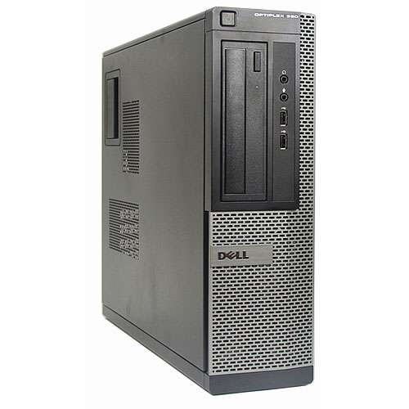
* 2 ASUSPro Series i5 core
  + 
* 1 APC UPS XS1500
  + 
* 1 Cisco SG300-52 port gigabit managed switch
  + 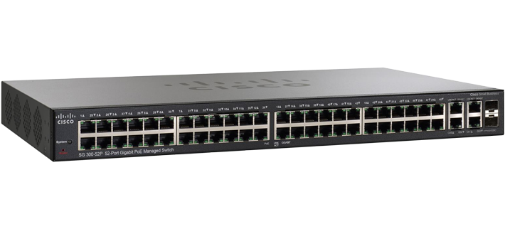
* 1 Dell VGA monitor
  + 
* 4 Crucial 250GB SSD hard drives (upgrade)
  + 
* 1 gigabit network card
  + 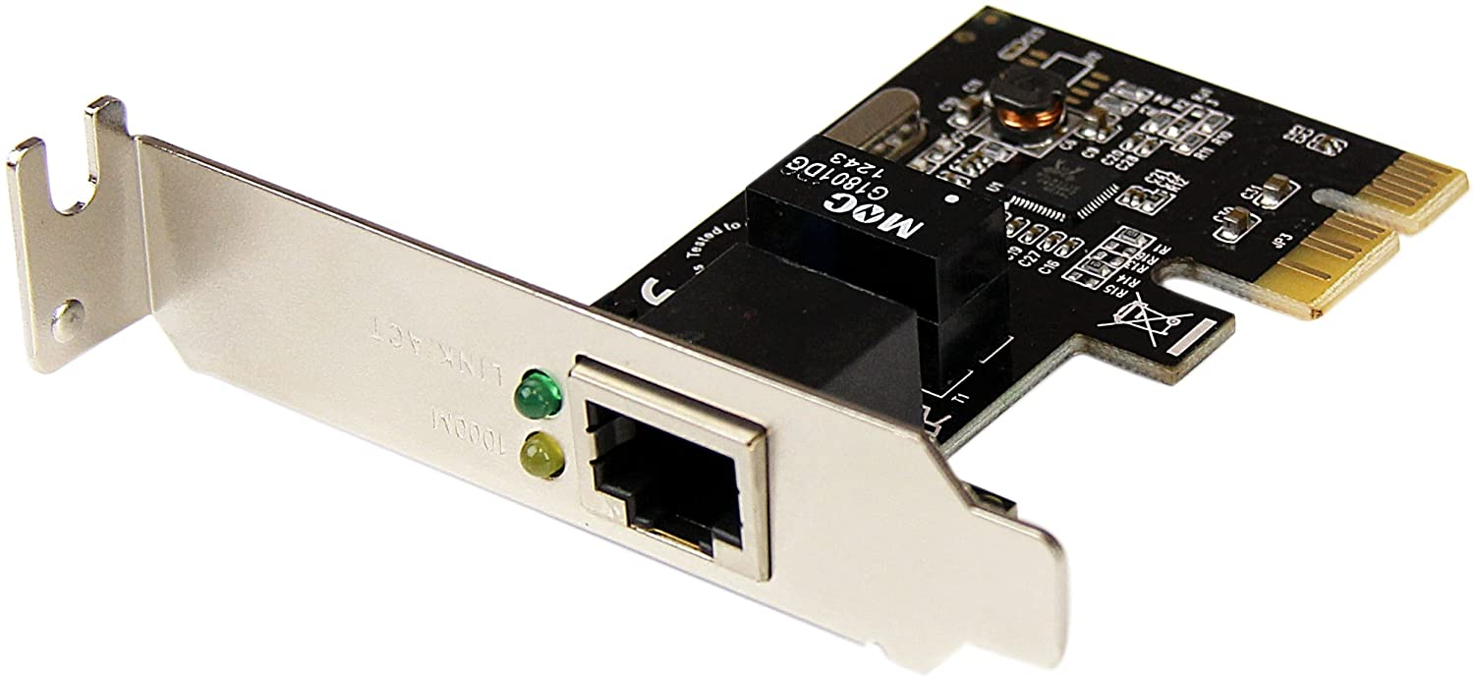
* 6 Cat6 network cables
  + 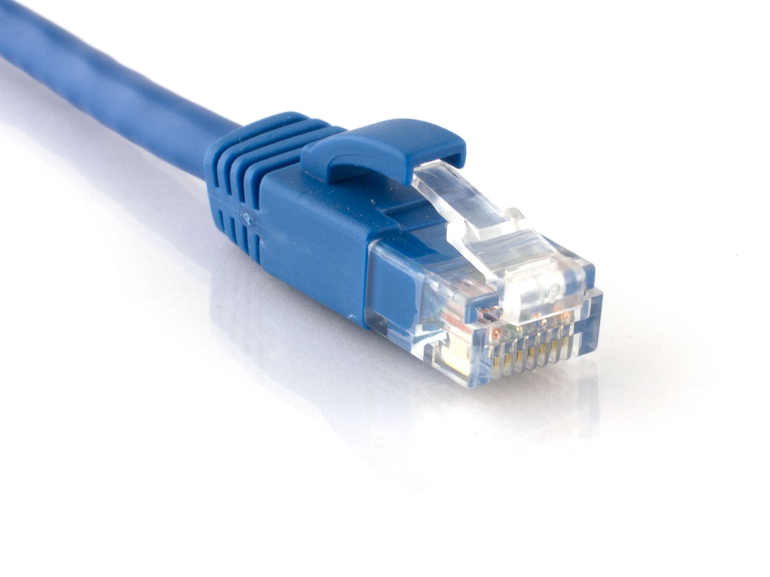
* Keyboard and mouse
  + 
* Sandisk 16GB USB 2.0 drive
  + 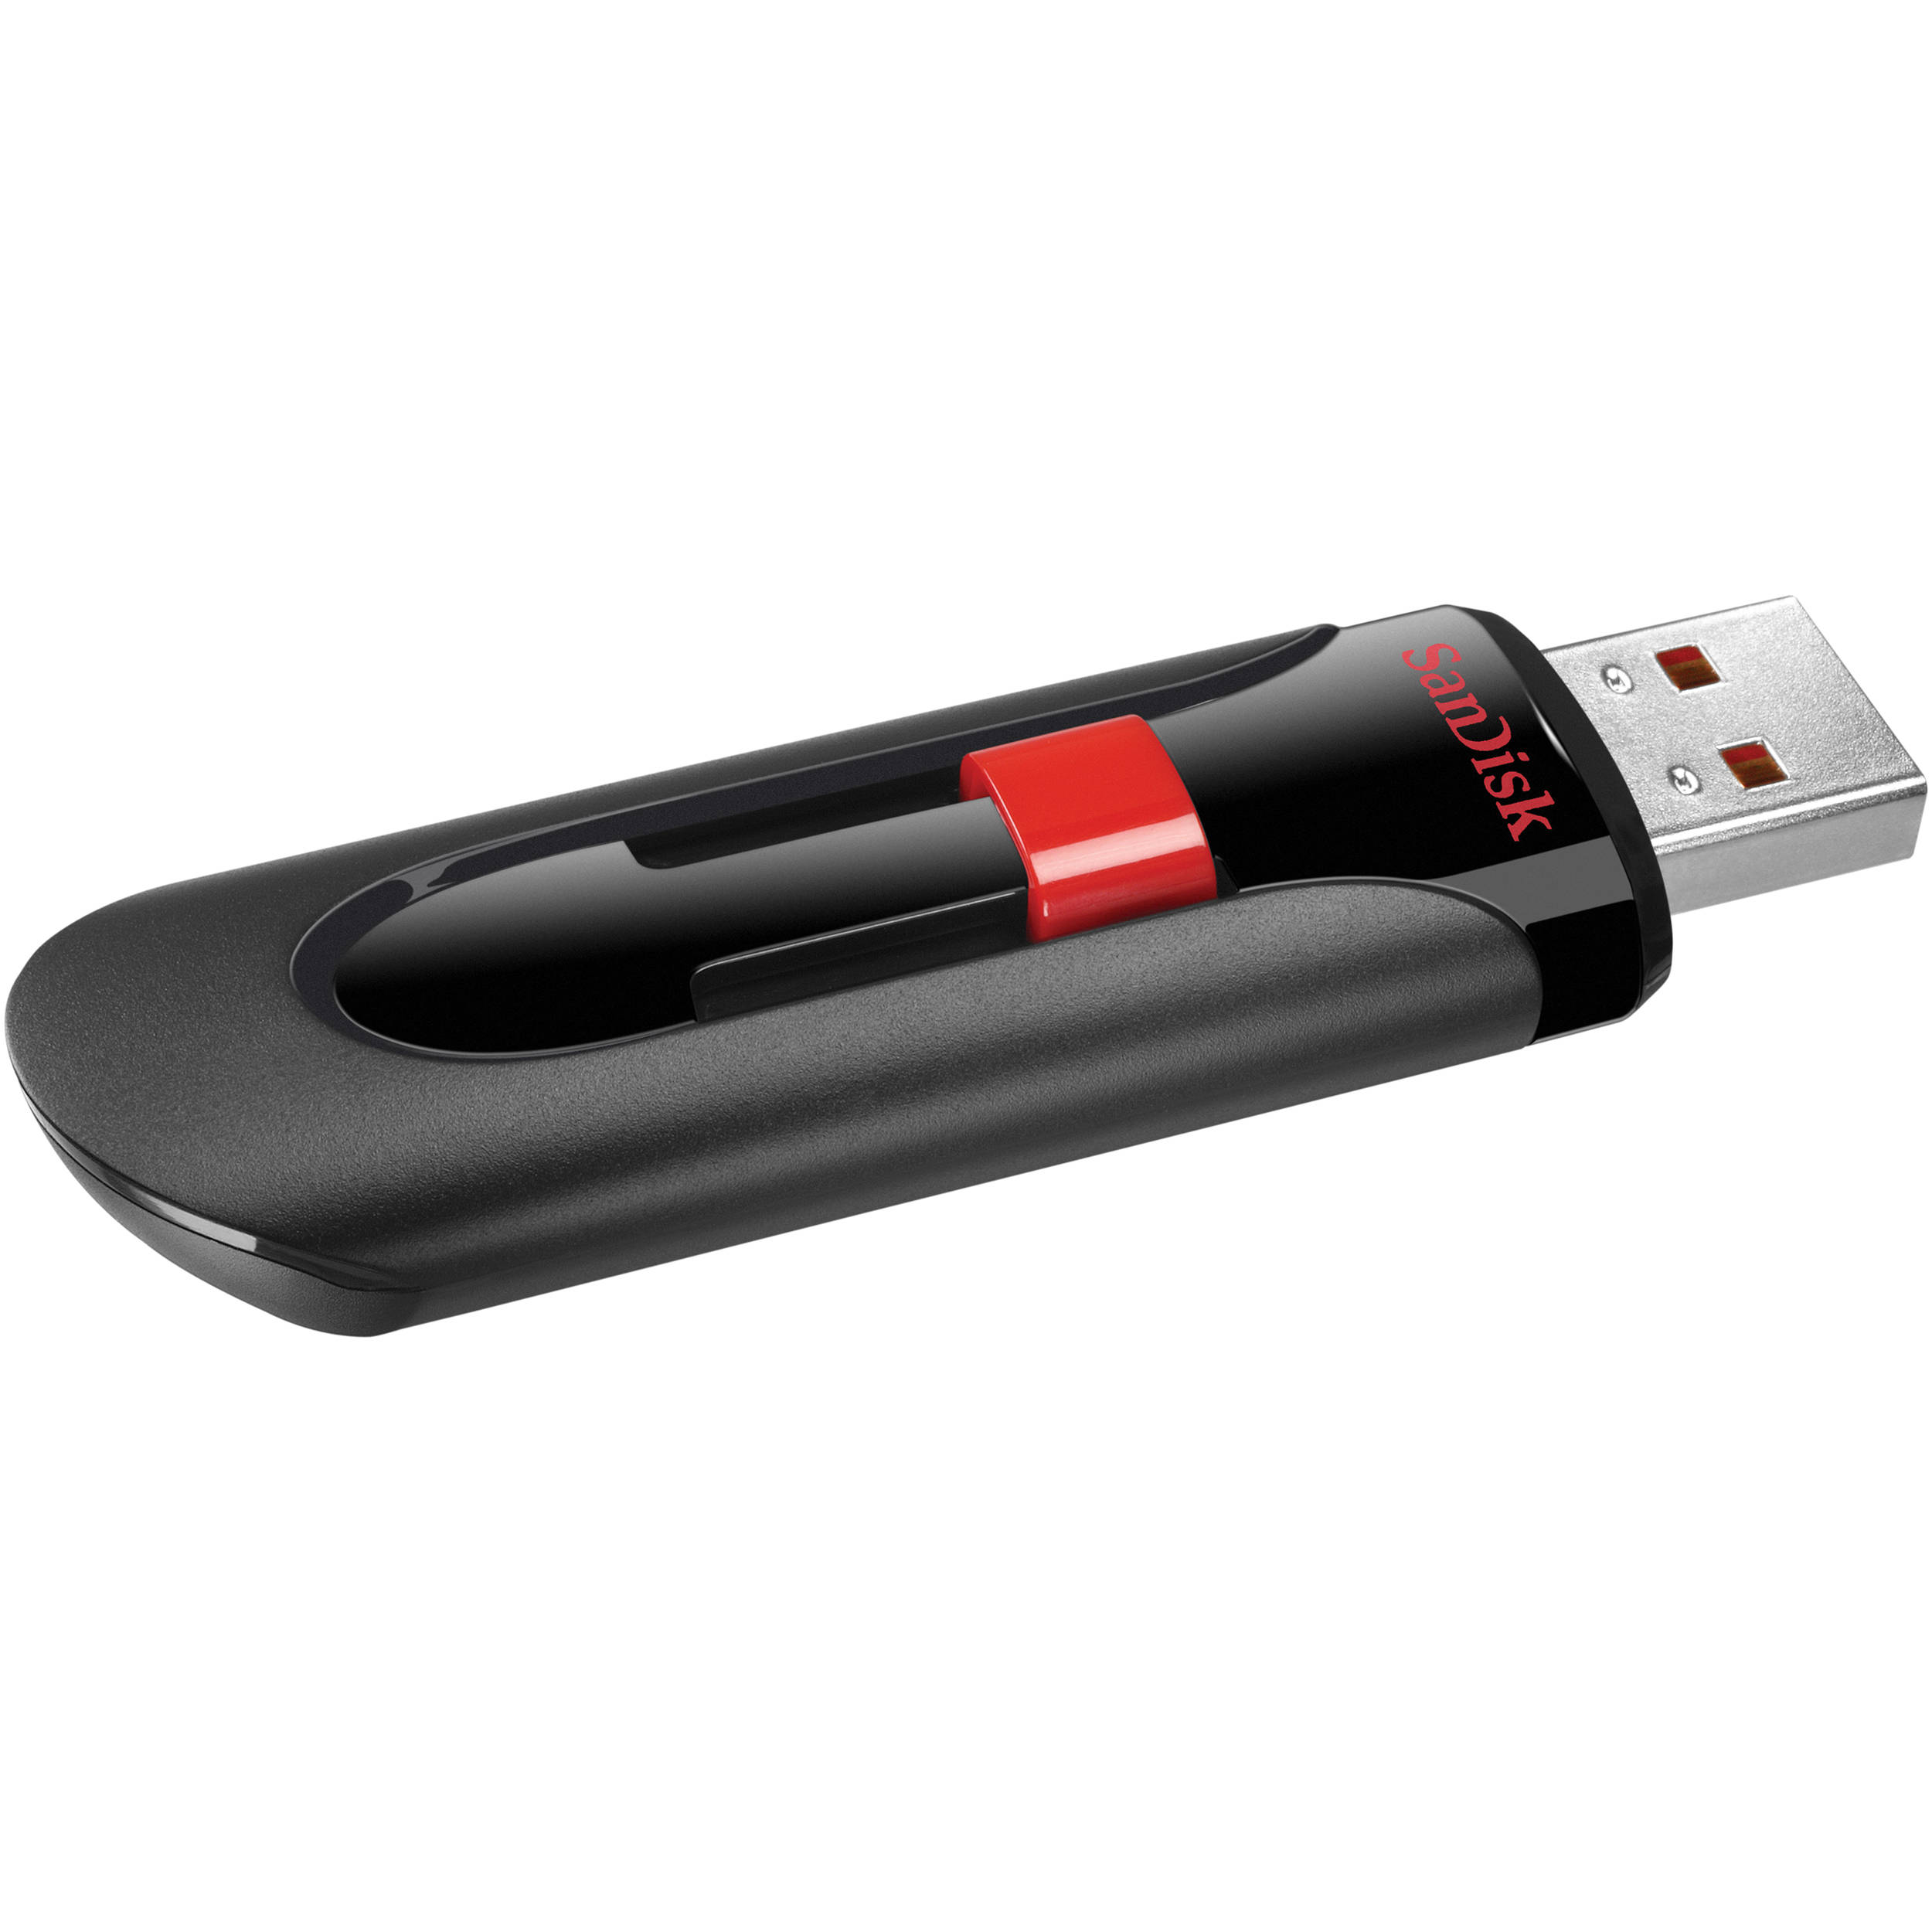

### Software used

* Microsoft Project 2019
* Microsoft Word 2019
* Microsoft Windows 10 v 1909
* Balena etcher v1.5.59
* Putty64_bit release 0.73
* Mozilla Firefox v75.0
* Solidworks 2018 SP1.0
* ROCKS 7.0 Manzanita (centOS 7.4)
  + CentOS kernel v7.4
  + Sun Grid Engine v7.0
  + Base Roll v7.0
  + Core Roll v7.0
  + Updates-CentOS Roll v7.0
  + Ganglia v7.0
  + Area 51 v7.0
  + Fingerprint v0.3
  + Hpc v7.0
  + Htcondor v8.6.8
  + Java v7.0
  + Python v2.7.6 and 3.3.4

# IV. Usability Test

## Introduction

Building a high performance compute cluster from old computer hardware, to run massive data calculations, or prediction models, or decode strands of DNA sequences, is not an easy task. To test my cluster I found a program to calculate the decimal points of Pi, utilizing the Python programming language. The usability test will show that the technical manual and Python program was instrumental to a successful installation and production run of a compute cluster. The test environment used was a virtual cluster utilizing Oracle VMbox, each user was asked to install a new cluster configuration onto a standard computer with at least 4 CPUs, and 8 GB of RAM. For the test VLAN setup we used CISCO GNS3 switch emulation. Users were asked to complete a series of routine tasks. Sessions were recorded and analyzed to identify potential areas for improvement to the technical manual.

## Executive Summary

Rory Stouder conducted a remote usability test utilizing Microsoft Teams to remotely view the users’ computer, during the week between 4/13/2020 through 4/19/2020. The purpose of the test was to assess the usability of the technical manual design, information flow, and information architecture.

Three users were asked to perform the test via remote viewing. Each individual session lasted approximately two hours. Test scenarios and conditions differed between each user, but all tests were performed.

In general all participants were able to follow through the manual to completion. All three users are familiar with computer administration and the installation of a Linux operating system, and software.

The test identified only a few minor problems including:

* Lack of a troubleshooting section
* Disruption of information flow when moving from section to section.

This document contains the participant feedback, task completion rates, difficulty of completion ratings, time on task, errors, and recommendation for improvements.

## Methodology

### Sessions

I contacted and recruited participants in the test from friends that I am familiar with and know have computer skills, required to complete the installation and administration. I sent e-mail requests to participants informing them of the test and requesting their availability and participation. Participants responded with an appropriate date and time. Each individual session lasted approximately two hours. During the session, the test administrator explained the test session.

After each task, the administrator asked the participant to rate the usability of the manual on a 5-point Likert Scale, with measurements ranging from Strongly Disagree to Strongly Agree. Post-task scenario subjective measures included:

* It was easy to find the information and follow the instructions on setting up the VLAN?
* It was easy to find the information and download the required files to flash a USB?
* It was easy to find the information and install the ROCK OS on the front node in the cluster?
* It was easy to add node computers to the cluster once the frontend was set up?

After the last task was completed, the test administrator asked the participant to rate the manual overall by using a 5-point Likert scale (strongly disagree to strongly agree) for eight subjective measures including:

* Ease of use
* Frequency of use
* Difficulty in keeping track of the point in the installation procedure.
* Learnability - how easy would it be for most users to learn this installation procedure.
* Information facilitation - how quickly did the participant find information
* Look & feel appeal - Overall UI pleasantly designed?
* Manual content - does the manual contain all the information needed to complete the tasks
* The organizational structure of the manual
* What the participant liked the most
* What the participant liked the least
* Recommendation for improvement.

## Participants

All participants are information technology professionals, with experience installing and maintaining computer hardware and software. These participants were chosen so that an accurate usability of potential users is taken into account. It is rare that a lay computer user would want to install and maintain a High performance compute cluster.

### Roles

|  |  |  |
| --- | --- | --- |
| Network Administrator | Technology Director | CIO |
| 1 | 1 | 1 |

#### Evaluation Tasks/Scenarios

In creating the tasks I chose several tasks that need to be completed to run a successful install of a ROCKS high performance compute cluster.

1. Setup Virtual Local Area Network on a Cisco Router
2. Flash the installation files to a flash drive and confirm success.
3. Install Oracle VirtualBox for the virtual cluster installation.
4. Boot Frontend node with Kernel and install all Cluster Rolls.
5. Boot Compute nodes and insert them into the cluster.
6. Run shell script to calculate Pi to one million decimal points.

## Results

### Task Completion Success Rate

All participants successfully completed tasks 1-6.

|  |  |  |  |  |  |  |
| --- | --- | --- | --- | --- | --- | --- |
| Participant | Task 1 | Task 2 | Task 3 | Task 4 | Task 5 | Task 6 |
| 1 | X | X | X | X | X | X |
| 2 | X | X | X | X | X | X |
| 3 | X | X | X | X | X | X |
| Success | 3 | 3 | 3 | 3 | 3 | 3 |
| Completion Rates | 100% | 100% | 100% | 100% | 100% | 100% |

### Task Ratings

After the completion of each task, participants rated the ease or difficultness of completing the task for three factors:

* It was easy to follow along with the information in the step
* As I was following the steps it was easy to keep track of where I was in the process.
* I was able to accurately complete all the steps

The 5-point rating scale ranged from 1 (Strongly disagree) to 5 (Strongly agree). Agree ratings are the agree and strongly agree ratings combined and averaged.

#### Following along with the information in the steps

All the participants found it easy to follow along with the steps in the manual. The mean agreement rating = 4.36. In addition, with a mean rating of 4.3 the users found it easy to set up the VLAN. The installation of the Operating system scored a 4.0 average rating. Flashing the USB received an average of 5.0. The installation of Oracle Virtual Box scored a 4.6 average. Booting the Frontend node scored an average of 4.0 and adding the compute nodes scored 5.0. The last step compiling and computing Pi to one million decimal places scored a 4.3.

#### Keep track of progress

All the participants found it easy to keep track of progress in the manual. The mean agreement rating = 4.1. Setup VLAN scored a 4.3. Flashing the USB scored 4.0. Installing Oracle Virtual Box scored a 4.0. Installing the frontend node scored 4.0. Setting up the compute nodes scored a 4.0. Lastly the calculating of Pi to one million digits scored 4.3

#### Accurately complete all steps

All the participants found it easy to complete all the steps in the manual. The mean agreement rating = 5.0. All steps scored 5.0 as each step was completed successfully in the time frame allotted.

|  |  |  |  |  |
| --- | --- | --- | --- | --- |
| Task | Ease- Following | Step tracking | Completion rate | Overall |
| 1 - Setup VLAN | 4.0 | 4.3 | 5.0 | 4.43 |
| 2 - Flash USB | 5.0 | 4.0 | 5.0 | 4.66 |
| 3 - Install Oracle Virtual Box | 4.6 | 4.0 | 5.0 | 4.53 |
| 4 - Install Front node | 4.0 | 4.0 | 5.0 | 4.33 |
| 5 - Compute Node | 5.0 | 4.0 | 5.0 | 4.66 |
| 6 - Calculate Pi | 4.3 | 4.3 | 5.0 | 4.53 |

### Time on Task

The stopwatch feature on my iPhone was used to record the time each user spent on each task. Task 4 required the downloading of 4 GB of data and required the longest time to complete. The time will be displayed in HH:MM:SS format

|  |  |  |  |  |
| --- | --- | --- | --- | --- |
|  | P1 | P2 | P3 | Avg. Total |
| Task 1 | 00:10:32 | 00:12:37 | 00:11:24 | 00:11:31 |
| Task 2 | 00:07:25 | 00:07:42 | 00:07:30 | 00:07:32 |
| Task 3 | 00:15:24 | 00:17:45 | 00:15:54 | 00:16:21 |
| Task 4 | 01:12:33 | 01:22:34 | 01:17:24 | 01:17:31 |
| Task 5 | 00:07:55 | 00:08:46 | 00:08:22 | 00:08:21 |
| Task 6 | 00:22:54 | 00:24:24 | 00:23:52 | 00:23:44 |

### Errors

The participants made only a few errors, mostly during the transition between steps. On transition from flashing the USB to installing Oracle Virtual Box, it is confusing because the steps are different than when installing on a real computer.

|  |  |  |  |  |
| --- | --- | --- | --- | --- |
| Task | Task Completion | Errors | Time on Task | Satisfaction |
| 1 | 3 | 0 | 00:11:31 | 4.43 |
| 2 | 3 | 2 | 00:07:32 | 4.66 |
| 3 | 3 | 1 | 00:16:21 | 4.53 |
| 4 | 3 | 0 | 01:17:31 | 4.33 |
| 5 | 3 | 0 | 00:08:21 | 4.66 |
| 6 | 3 | 0 | 00:23:44 | 4.53 |

*Satisfaction = Mean combined rating across three post-task measures: ease of finding information, keep track of progress, and completion rate.

## Overall metrics

### Overall Ratings

After task session completion, participants rated the manual for eight overall measures:

* Ease of use
* Frequency of use
* Difficulty in keeping track of the point in the installation procedure.
* Learnability - how easy would it be for most users to learn this installation procedure.
* Information facilitation - how quickly did the participant find information
* Look & feel appeal - Overall UI pleasantly designed?
* Manual content - does the manual contain all the information needed to complete the tasks
* The organizational structure of the manual

A majority of the participants (100%) agreed that the manual was easy to use. The majority of participants (93%) agreed that they would use the manual again if they needed to repeat these steps at a future date. Only one participant (66%) agreed that the look and feel of the overall UI was pleasantly designed.

|  |  |  |  |  |  |  |  |
| --- | --- | --- | --- | --- | --- | --- | --- |
|  | **Strongly Disagree** | **Disagree** | **Neutral** | **Agree** | **Strongly Agree** | **Mean Rating** | **Percent Agree** |
| ease of use |  |  |  |  | 3 | 5.0 | 100% |
| Frequency of use |  |  |  | 1 | 2 | 4.6 | 93% |
| Keeping track of location |  |  |  | 1 | 2 | 4.6 | 93% |
| Learnability |  |  |  | 2 | 1 | 4.3 | 86% |
| Information facilitation |  |  |  | 2 | 1 | 4.3 | 86% |
| Look & Feel |  |  | 2 | 1 |  | 3.3 | 66% |
| Content |  |  | 1 | 1 | 1 | 4 | 80% |
| organization |  |  | 1 | 1 | 1 | 4 | 80% |

### Likes, Dislikes, Participant Recommendations

#### Like Most

“I appreciated the addition of screenshots to accompany the written directions.”

#### Liked Least

“It would be easier to use if the manual was in a web-page or had a search function. So that you can stop and start at will.”

#### Recommendations for Improvement

“Make the manual searchable maybe with an SQL database.”

The results of these user tests of the manual showed that the steps in the manual are adequate to reproduce the results of the project. As the tests were completed successfully by three different persons across different hardware platforms.

# V. Project Management

## Schedule and Time Management

### Research

* 1. Research Operating Systems used in running a HPC cluster
     1. Research for Ubuntu Beowulf cluster
     2. Research for ROCKS centOS 7.0 cluster
  2. Research hardware requirements.
  3. Research networking requirements

### Primary Planning

* 1. Work breakdown structure strategy
  2. Budget planning
  3. Corporate sponsorship procurement

### Hardware

* 1. Procurement
     1. Cluster will need at minimum 3 computers
     2. Will need a gigabit managed network switch
     3. 6 outlet battery backup 1500 watt.

### Software

* 1. Download Ubuntu server 18.04 and Rocks Kernel for centOS 7.0
     1. Build Virtual HPC
        1. Install and Configure ROCKS cluster
           1. Test configuration
        2. Install and Configure Ubuntu Cluster
           1. Test configuration

1. Proof of concept in virtual environment

### Primary Project Construction

* 1. Build a wooden frame to hold HPC computers, switch, and battery backup.
  2. Configure VLAN on Gigabit network switch
     1. At least two ports for public internet (DHCP)
     2. The rest of the ports for the compute cluster (DHCP)
  3. Install base OS kernel on Master-node
  4. Setup environment on Master-node
     1. Installation of Cluster control, benchmarking, and production server.
  5. Update system and add a new user
     1. Compile ROCKS Roll for compute nodes distribution
  6. Install and configure compute cluster nodes
  7. Compile bash shell script to run Pi calculation.

### Documentation

* 1. Compile documentation of installation procedure
  2. Compile documentation for hardware specifications
  3. HPC Cluster production Run testing wrap and data collection
  4. Powerpoint presentation
  5. Compile project binder
  6. Submit project binder

The actual hours spent and the planned hours were only off by about 16 hours, as stated above in the Work Schedule section of the planning I planned to work 16 hours a week on the project mainly during the weekend, I used a to-do list to keep on track with the schedule. Most of the time overages were in the documentation of this manual as there wasn’t any real direction early on as to what the manual should contain, only an outline, so much time was spent looking up outside examples, as they weren’t provided by the school. Guessing what the requirements are for something always requires more time to complete, it would have cut the time spent dramatically if actual examples and requirements were given at the beginning of the semester.

## Resource and Cost Management

I used Microsoft Project to manage resources. Management of costs I used the tried and true technique of, implementing and decision tree, first asking what it is for, then is it needed, if those two questions couldn’t be answered with certainty I wouldn’t buy it. I also asked for and received corporate sponsorship from Flexaust inc, which I used equipment they were about to recycle, which kept the budget to under $1,000.

## Quality Management

I utilized the system of quality management that implements these styles, quality planning, quality assurance, quality control and quality improvement. I followed the plan, and assured that each step was completed before moving on to the next, by testing the function of that task would result in the desired outcome. This testing ensured that there is control over the quality of the product, and that if improvements were needed they would be brought to light. This resulted in a total reinstallation of the cluster 3 times, first with Linux and second with the ROCKS cluster twice, before I felt I had a quality installation.

## Risk Management

**Primary Technical Risk:**  Unable to get CPUs to schedule or share Jobs resources  
**Primary Schedule Risk:** Only one semester to plan and execute   
**Primary Cost Risk:** Losing my job and support of the company supplying computers.

**Primary Unforeseen Risk:** Covid-19 Pandemic

I approached each of these risks with alternative plans incase each of these risk arrose, except for the unforeseen risk of the pandemic, which ended up not really affecting the schedule, cost or was actually a risk for completion, in reality it was a benefit for me, because I was able to work from home and spend more time than I would of had otherwise.

# VI. Issue Log & Lessons Learned

### Issue Log

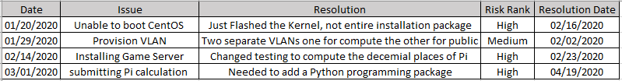

During the development of this High Performance Compute Cluster I encountered three issues I had not anticipated, and one issue which I had. Starting with the issue I had anticipated, the provisioning on the virtual local area networks needed to separate the frontend public facing portal, from the compute network. I was able to utilize resources that the company i work for has, in asking our network administrator how to perform the required network provisioning. While this was considered a low risk in the beginning it was later determined to be a very minor risk compared to the later issues that arose.

Being unable to boot the installation media as a very high risk. When I researched this process I started out using a youtube video on how to install the Cluster, and tried to recreate the process on my hardware. The recreation failed, and I had to try a different approach, after several trials and at least one night to sleep on the problem, I figured out that you only needed to flash the kernel, and not the DVD package. After just flashing the boot kernel, I was able to finish installing the cluster.

After the cluster was up and running my next order of business was to install a game server, but this is not what the intended purpose of a High performance compute cluster. The compute cluster is used to run calculations on more CPUs than are normally contained in a desktop computer. The custom Linux distribution wasn’t able to run a gaming server, so I switched to running a calculation operation, and calculated Pi to one million decimal places.

After switching the testing to the compute function of calculating Pi to one million decimal places, there became the issue of submitting the job for calculation. I needed to add a math compute function to the Python programming language package already installed, this process involved downloading and compiling the package within the kernel and then re-installing the kernel onto all of the nodes in the cluster.

### Lessons Learned

The lessons learned are that I was not adequately prepared for this senior project, the materials that were given to help one navigate the learning process were very thin, if there at all. There were absolutely no requirements clearly defined at any part, this taught me that you will come across a project in your life that hands you a bunch of junk and expects you to complete it without giving any indication of what exactly will happen, in short self-reliance.

I learned that sometimes the project you thought you were setting out to accomplish will not be the final product delivered, as vision and reality line up in their own way. I was able to build a super computer that talks to every node, but I didn’t understand how that functioned in reality until after I had a working cluster.

The pandemic was an unforeseen circumstance, but I have learned that it is only yourself that causes any risk to yourself in reference to a pandemic. There was not much that this affected, and it was easily overcome by only a slight adjustment to my schedule.

# VII. Installation Instructions

## Gather Computer Hardware.

1. Minimum 2 computers to make a cluster, one with two ethernet ports, and one Windows computer to perform downloads, and drive flashing.
   1. The computer with two ethernet ports is the Frontend node
   2. If not already installed, install a second network card in the open PCI slot on the motherboard.
2. Computers need 1 GB of RAM and 50GB of hard drive space for default CentOS 7.4 install
3. The compute node must be able to PXE network boot.
4. A managed Gigabit Ethernet switch, with 8 ports, and the ability to establish VLANs.
5. A battery backup for power redundancy
6. Cat6 Network cables
7. Monitor, keyboard and mouse.
8. Get a USB flash drive with 8GB of space minimum.

## Gather software for Installation.

1. Visit <http://www.rocksclusters.org/downloads.html> and download the newest version of the “Kernel Roll” currently Rocks 7.0 Manzanita (CentOS 7.4)
2. Visit <https://www.balena.io/etcher/> and download the program to flash ISOs to USBs
3. Any BIOS updates for the computers and network switch chosen.
4. Download Oracle VirtualBox from <https://www.virtualbox.org/wiki/Downloads> for Windows hosts
5. Download and install the Putty terminal program, on the windows machine. <https://the.earth.li/~sgtatham/putty/latest/w64/putty-64bit-0.73-installer.msi>

## Installation of Virtual Environment

1. Run installation file for Oracle VirtualBox.
2. Open Oracle VirtualBox

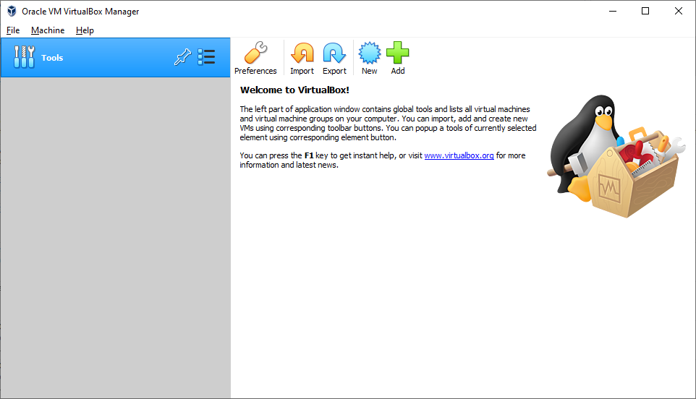

1. Select New, enter Name, Type is Linux, and Version is Redhat 64bit

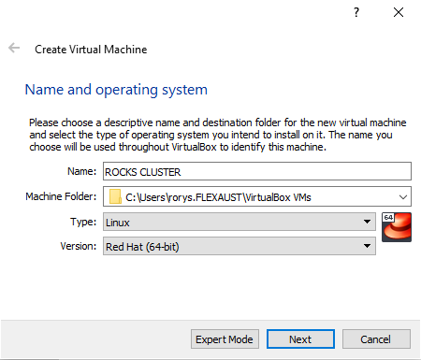

1. Click next and choose 2048MB of RAM

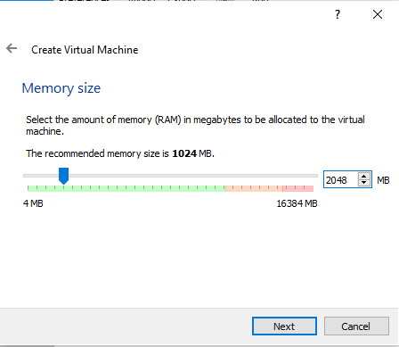

1. Click next and create a virtual hard disk now.

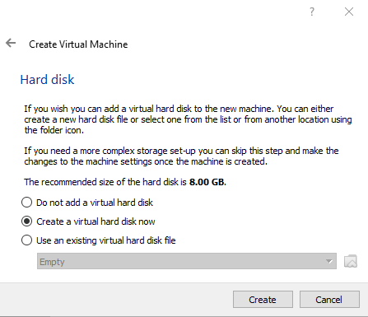

1. Click Create and stay with VDI (VirtualBox Disk Image)

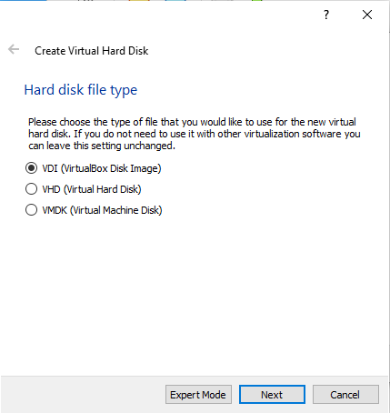

1. Click Next, and choose Dynamically allocated

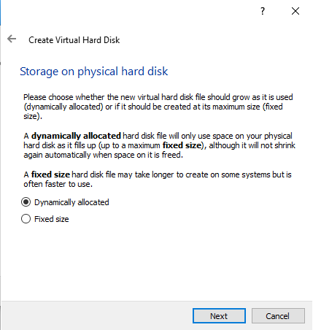

1. Click Next and change the allocation size to 32 GB

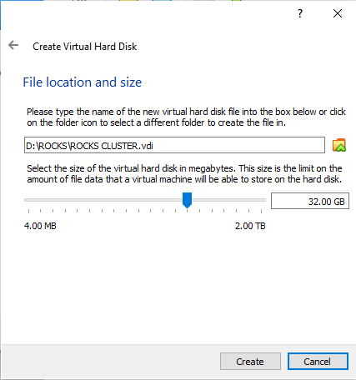

1. Click Create

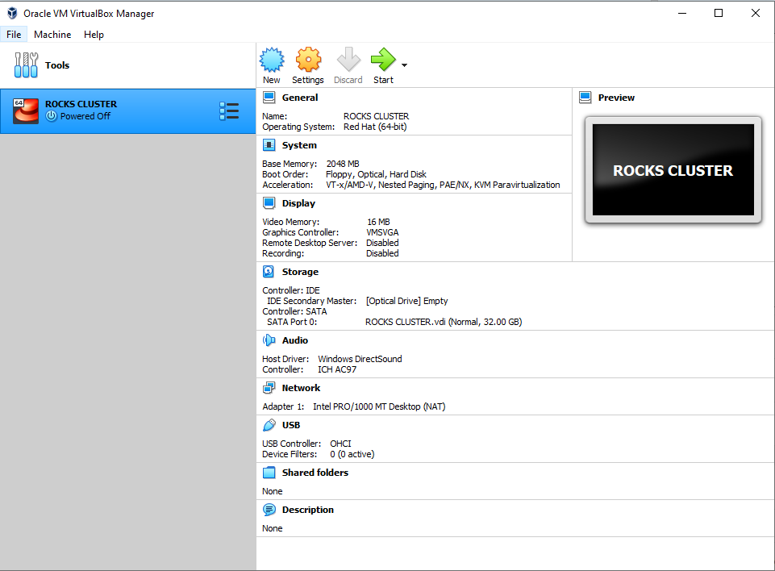

1. Select the Network Section, a new window will open.
   1. Change Adapter 1 from NAT to Internal Network

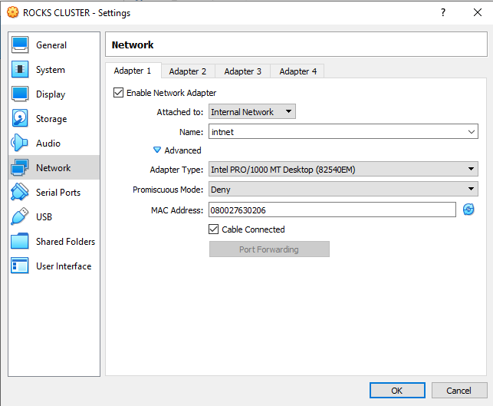

* 1. Select Adapter 2, enable the Network Adapter and set it to NAT

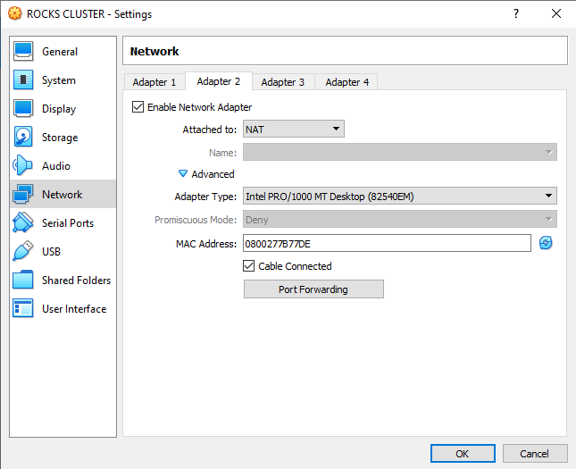

1. Select under the Storage section Controller: IDE [Optical Drive] Empty
   1. Choose a disk, and navigate to the place you saved the Kernel ISO

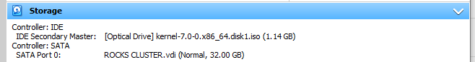

1. Click the Start Arrow, to boot the virtual machine

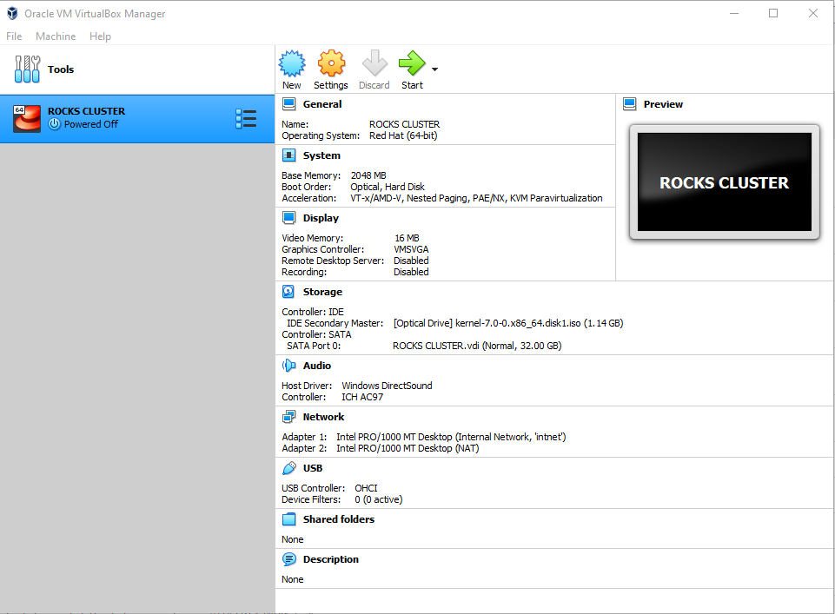

1. To complete virtual cluster setup continue to Section G Installing ROCKS on Frontend node

## Frame Construction and Computer Hardware Setup.

1. Gather wood for frame
   1. 1 piece of 6 inch by 1 inch by 8 feet
      1. Cut two pieces at 17 inches
      2. Cut two pieces at 18 inches
   2. 1 piece of 4 inch by 1 inch by 8 feet
      1. Cut two pieces at 17 inches
      2. Cut two pieces at 18 inches
   3. 1 piece of 2 inch by 1 inch by 8 feet
      1. Cut four pieces at 20 inches
2. Assemble the cut pieces into a frame (see appendix C for construction plans)
3. Attach wheeled casters
4. Place battery, computers, and network switch inside the frame
5. Hook up power cords
   1. Plug the forked end into the battery backup
   2. The other end goes into the back of the computer
6. Hook up power to network switch.
7. Hook up network cabling.
   1. From the frontend computer with two network cards, run a network cable from the factory installed network port to port #2 on the network switch.
   2. From the frontend computer’s secondary network card, run a network cable to port #3 on the network switch.
8. Hook up power to monitor.
9. Hook monitor cable to the frontend computer.
10. Hook up the mouse and keyboard to the frontend computer.
11. Plug the backup battery into the wall outlet and turn it on.

## Setting up Network VLAN

1. Navigate to the html portal on the managed device. (used in this build was a Cisco SG300-52p) will need a Windows 10 computer for this
   1. Open a browser window and type in default IP address supplied in the owner’s manual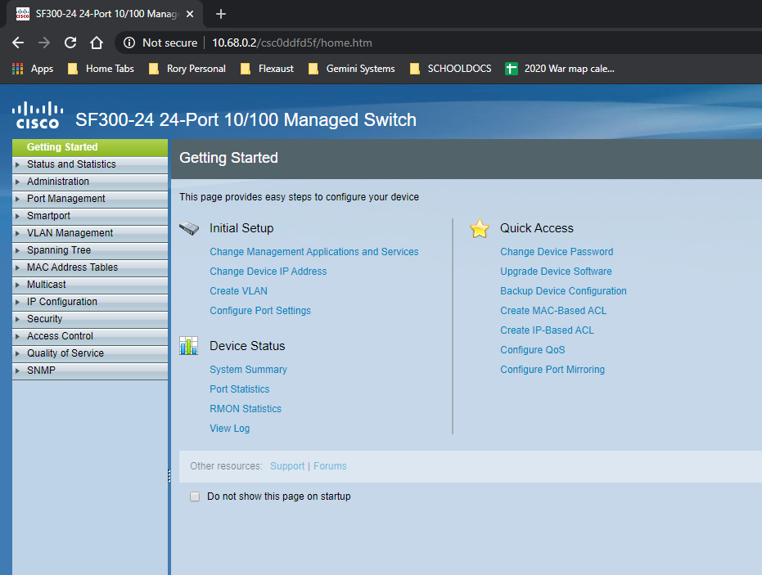
2. From the getting started page, select “Change Device Password”
   1. Select the cisco user account and click edit
   2. Enter a new password and confirm by clicking the “Apply” button.
   3. Under the Administration heading choose File Management
      1. Copy/Save Configuration
      2. Source file: running configuration / Destination File: Startup configuration
      3. Apply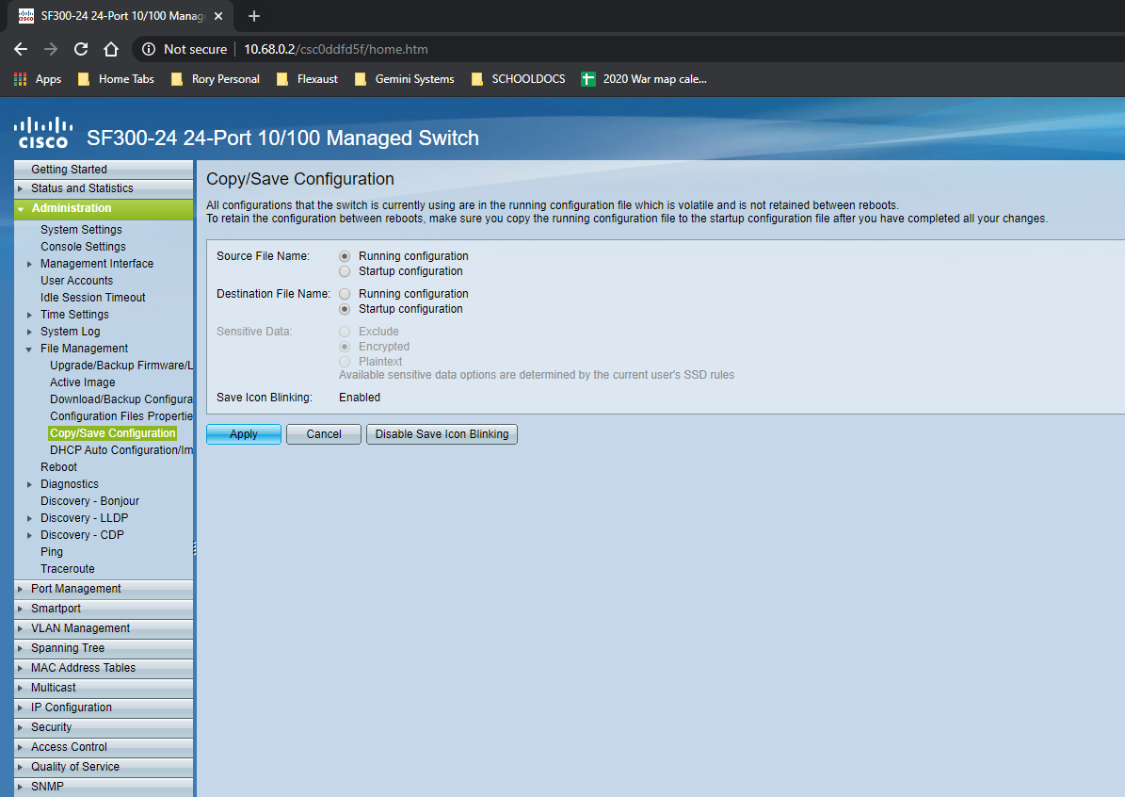
3. Select VLAN Management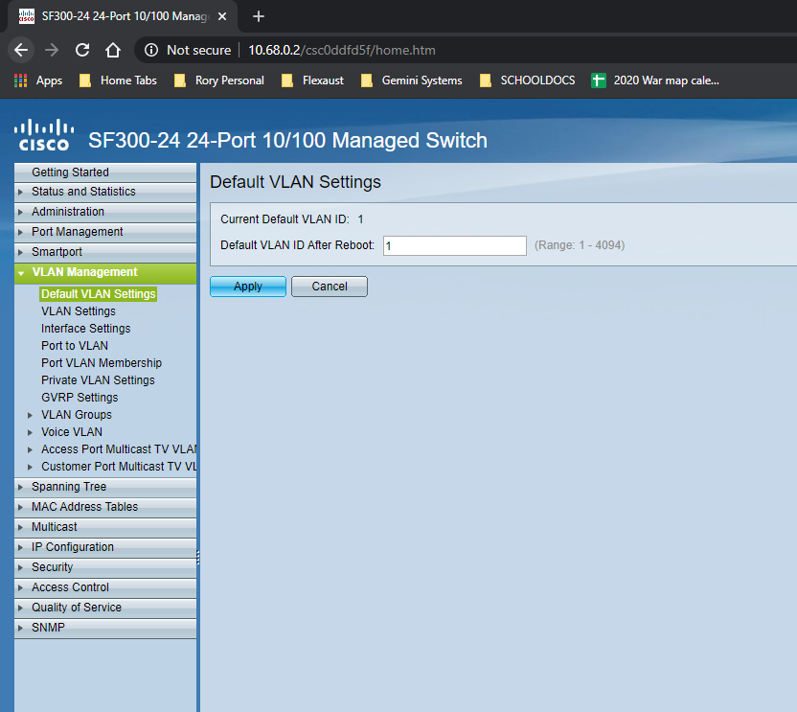
   1. Choose VLAN settings
      1. Add button
      2. Enter the desired VLAN ID: you can pick any number between 2 – 4094 (we chose 100 + 200)
      3. Enter the desired VLAN ID: We chose to name the VLAN with ID of 100 Public and the VLAN with ID of 200 Compute.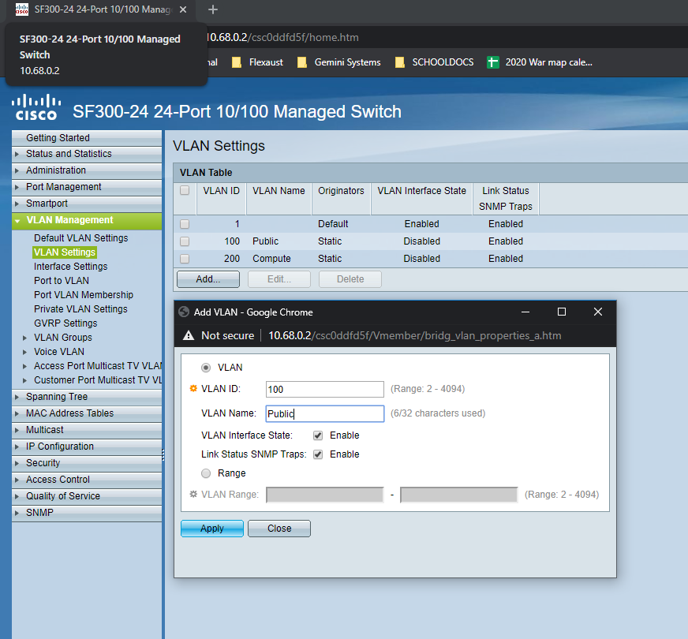
   2. Select Port VLAN Membership
      1. Radio button interface GE1 and click the “Join VLAN” button
      2. Select VLAN 100 and click the arrow button to move it to the right, click apply.
      3. Repeat for GE2, you can select the port from the drop down box at top.
      4. Select GE3, and add VLAN 200 to this port
      5. Repeat for the rest of ports needed for cluster computers.
4. Select Administration heading
   1. Choose File Management
      1. Copy/Save Configuration
      2. Source file: running configuration / Destination File: Startup configuration
      3. Apply
   2. Logout

## Flashing the ROCKS kernel onto USB drive.

1. Put the USB drive in an open USB slot of a computer, we used a Windows 10 computer for this step.
2. Open Balena Etcher and install with standard options.
3. Select the kernel ISO file downloaded in the second step.
4. Select the empty USB drive as the destination for the ISO flashing.

## Installing ROCKS on Frontend Node.

1. Power on the computer with the kernel USB drive flashed in the previous step inserted in an open USB slot.
   1. You may need to press F12 or F2 or Del to select the USB drive as the boot option. Consult your computer manual
2. After the frontend boots from the USB you will have two choices.
   1. Choose “Install Rocks 7.0” it will automatically choose this opting after 1 minute.

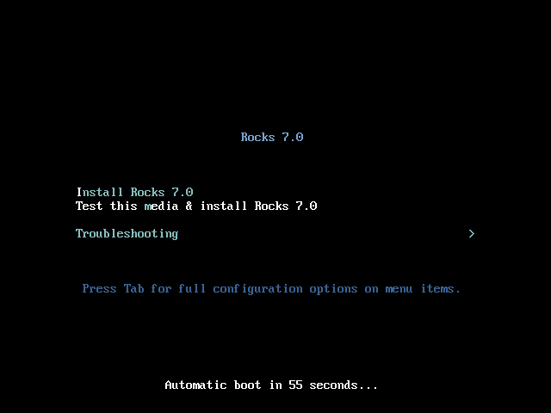

1. The kernel will boot to a custom graphical user interface, where you will select options for installation.
   1. Select your language preferences

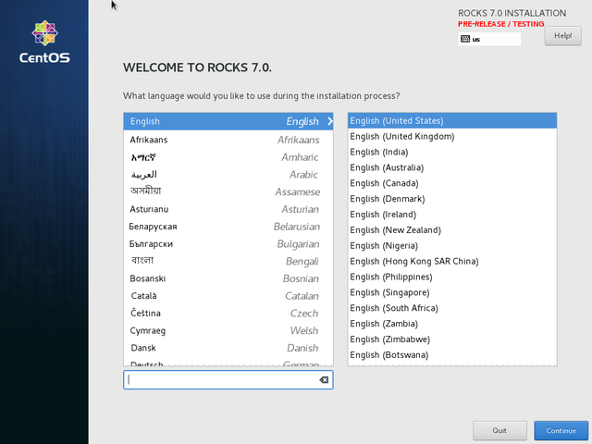

* 1. Configure your public network
     1. Scroll down to the “System” section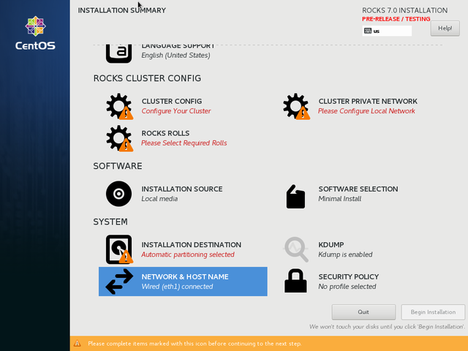
     2. Select “Network & hostname”
        1. Select “Ethernet (eth1)” click the Configure button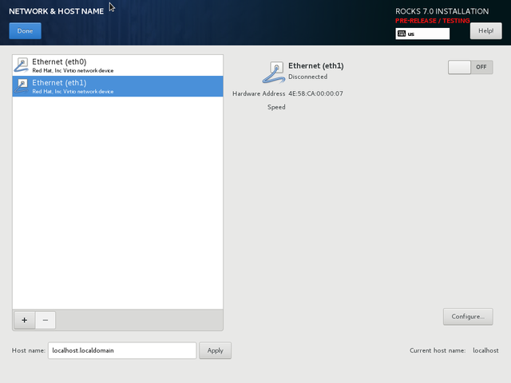
        2. Select the “IPv4 Settings” heading
           1. Under the Method drop down list, choose DHCP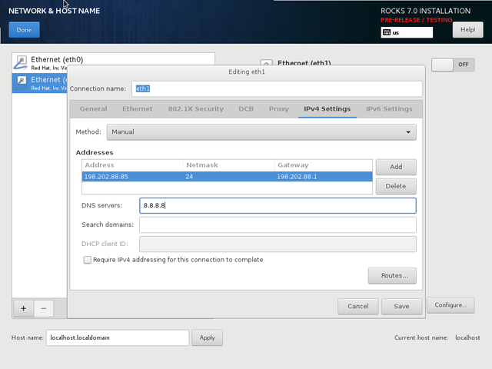
        3. Select the “IPv6 Settings” heading
           1. Under the Method drop down list, choose Link-Local Only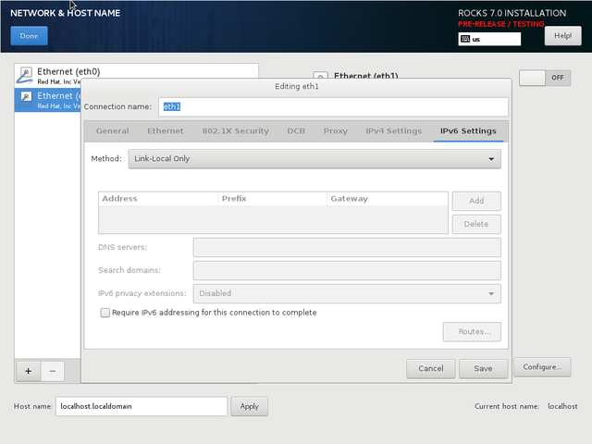
        4. Click Save
     3. Edit the entry at the bottom “Host name:” to be “your-host-name.localdomain” and click apply, then done.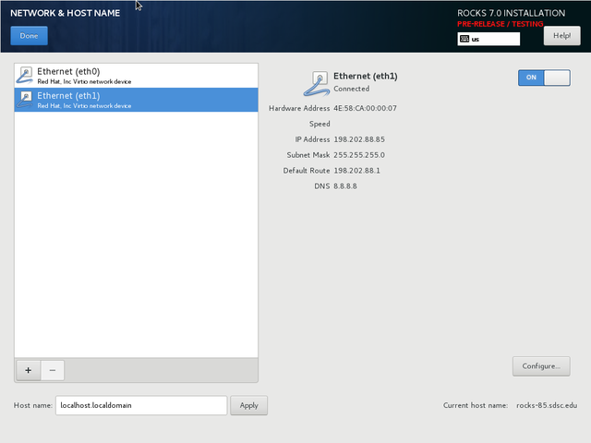
  2. Configure the local network
     1. Scroll up to the “Rocks Cluster Config” area.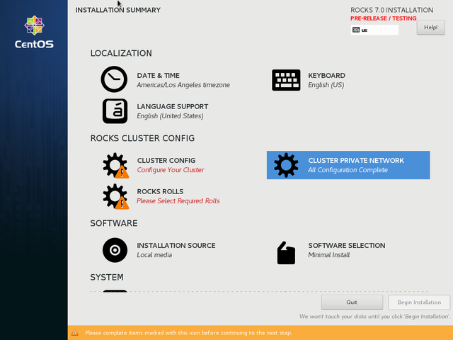
     2. Select “Cluster Private Network.”
     3. 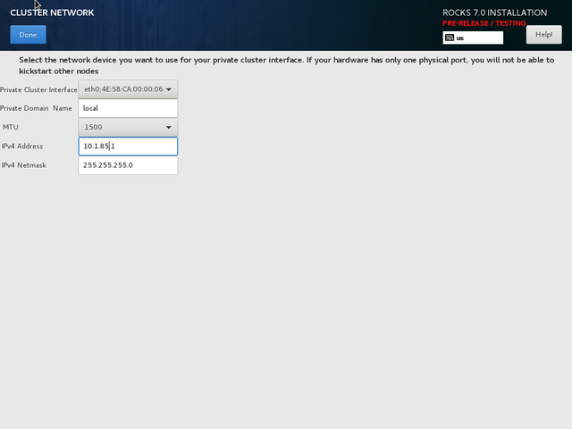
        1. Change MTU from 1500 to 9000
        2. Change IPv4 Address to 35.0.0.1
        3. Change IPv4 Netmask to 255.255.255.0
           1. You may select any IPv4 subnet you choose. However, conflict with the public network is not checked. Your public and private IP subnetworks must not overlap.
        4. Click Done
  3. Select the Rolls to install.
     1. Select the “Rocks Rolls” section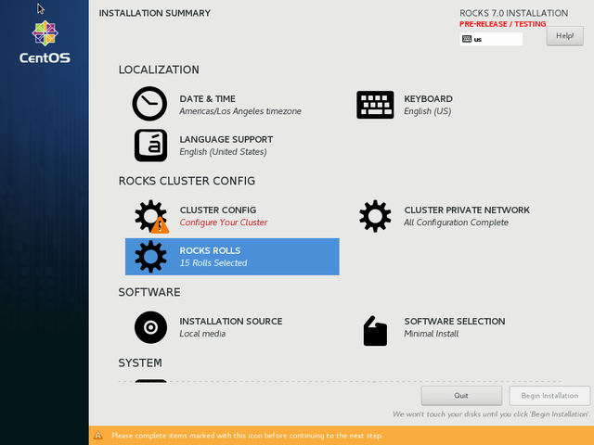
     2. At the top change the http address to <http://central-7-0-x86-64.rocksclusters.org/install/rolls> 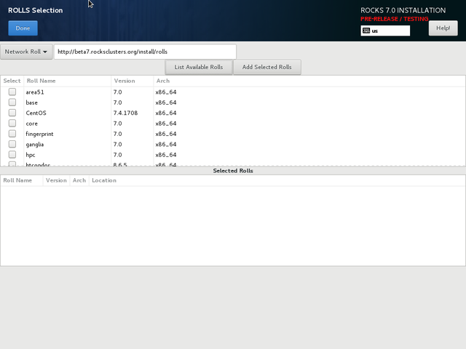
     3. Click “List Available Rolls” button to display all rolls
     4. Select every roll listed, and click the “Add Selected Rolls” button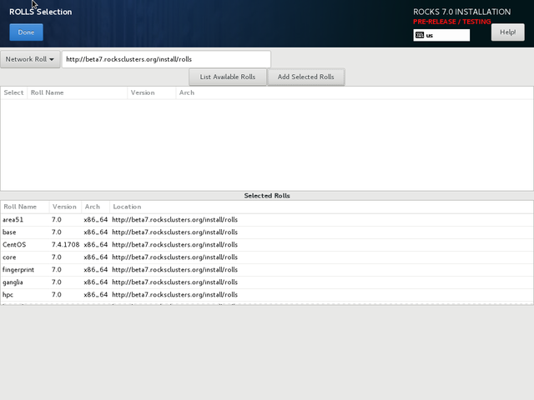
     5. Click Done
  4. Configure the Cluster
     1. Select the “Cluster Config” section.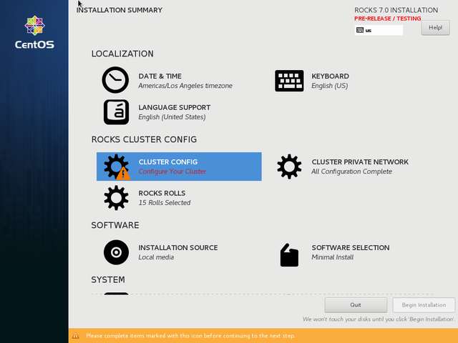
     2. You must enter a cluster name, this can be anything within 14 characters.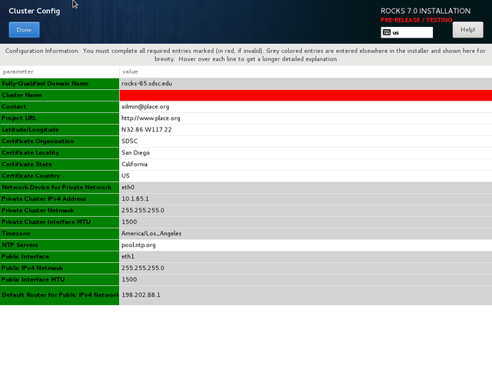
     3. Change the email address to your email address.
     4. Click “done”
  5. Choose Hard Drive to install the Rocks Cluster frontend onto.
     1. Select the “Installation Destination” section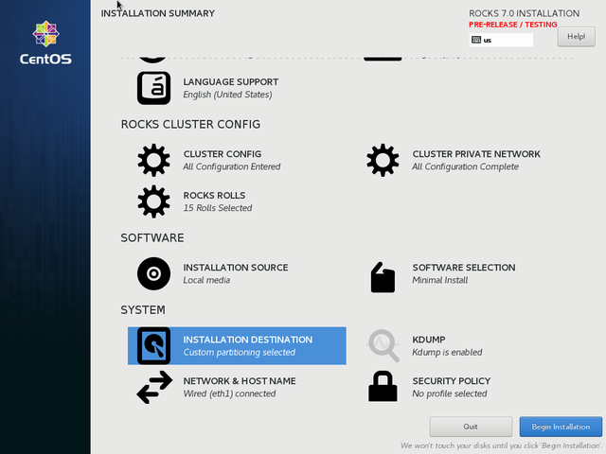
     2. Click the radio button “Automatically configure”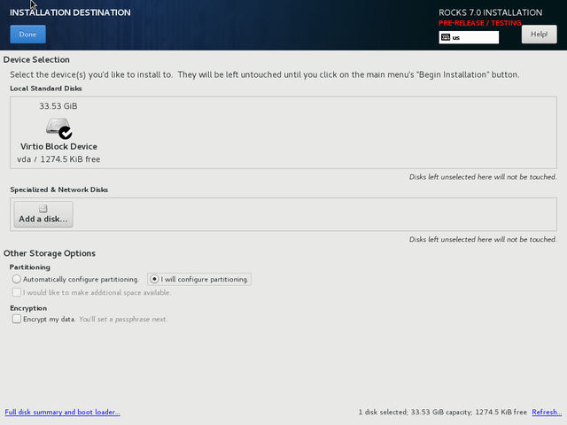
     3. Click Done

1. Begin Installation



* 1. Set Root Password

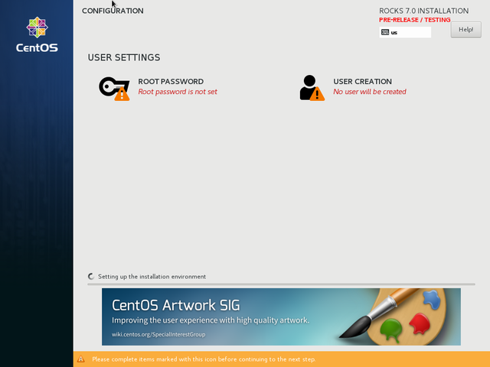

* 1. Create a user now for SGE roll use later.
  2. After installation – Reboot

## Install ROCKS on the Compute node.

1. Login to the Frontend node as Root
2. open a terminal session under the menu items at the top right of the screen.
   1. type “insert-ethers” (without the quotes) and choose “Compute”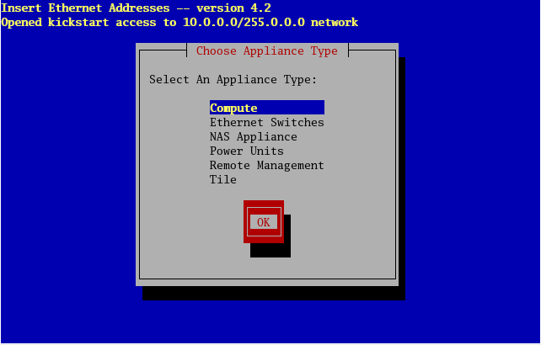
   2. you will see a screen that has a text box with heading “Inserted Appliances”

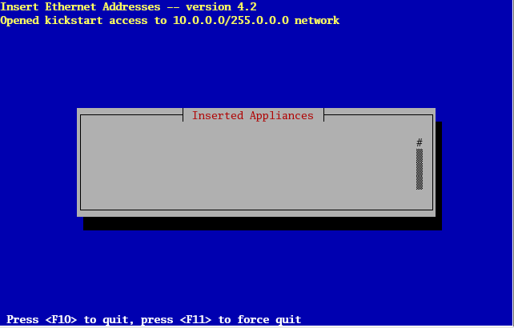

1. Power up the first compute node
   1. Press the delete key or F12 or F2 depending on requirement to enter BIOS or BIOS boot Options.
   2. Set as PXE boot only (consult computer manual documentation)
2. On the Frontend node you will see “Discovered a new appliance with MAC (00:13:72:BA:C8:DF)” the address will be different on your computer.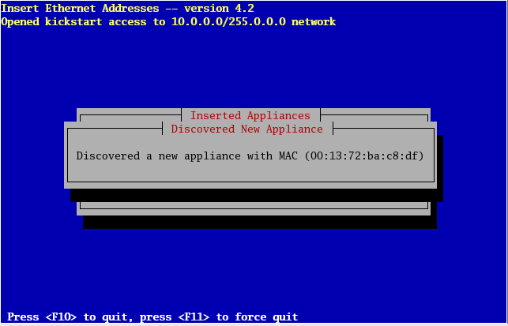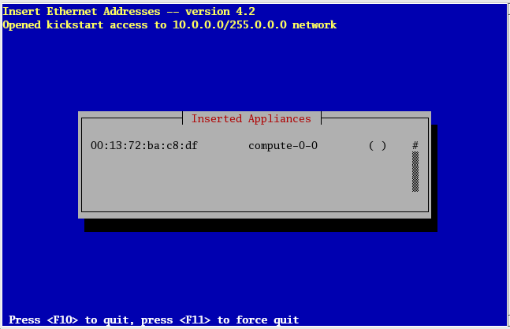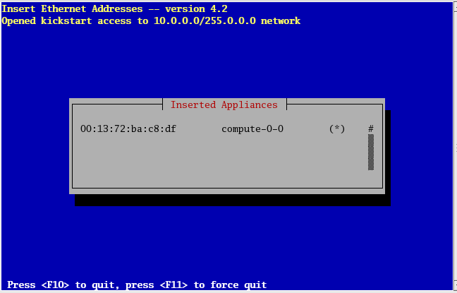
3. After repeating step three for each computer in the cabinet, press F10 to quit and save configuration.
4. Open Mozilla Firefox
   1. Go to “localhost”
   2. Click on Ganglia monitor - this displays a Graphical dashboard of cluster performance.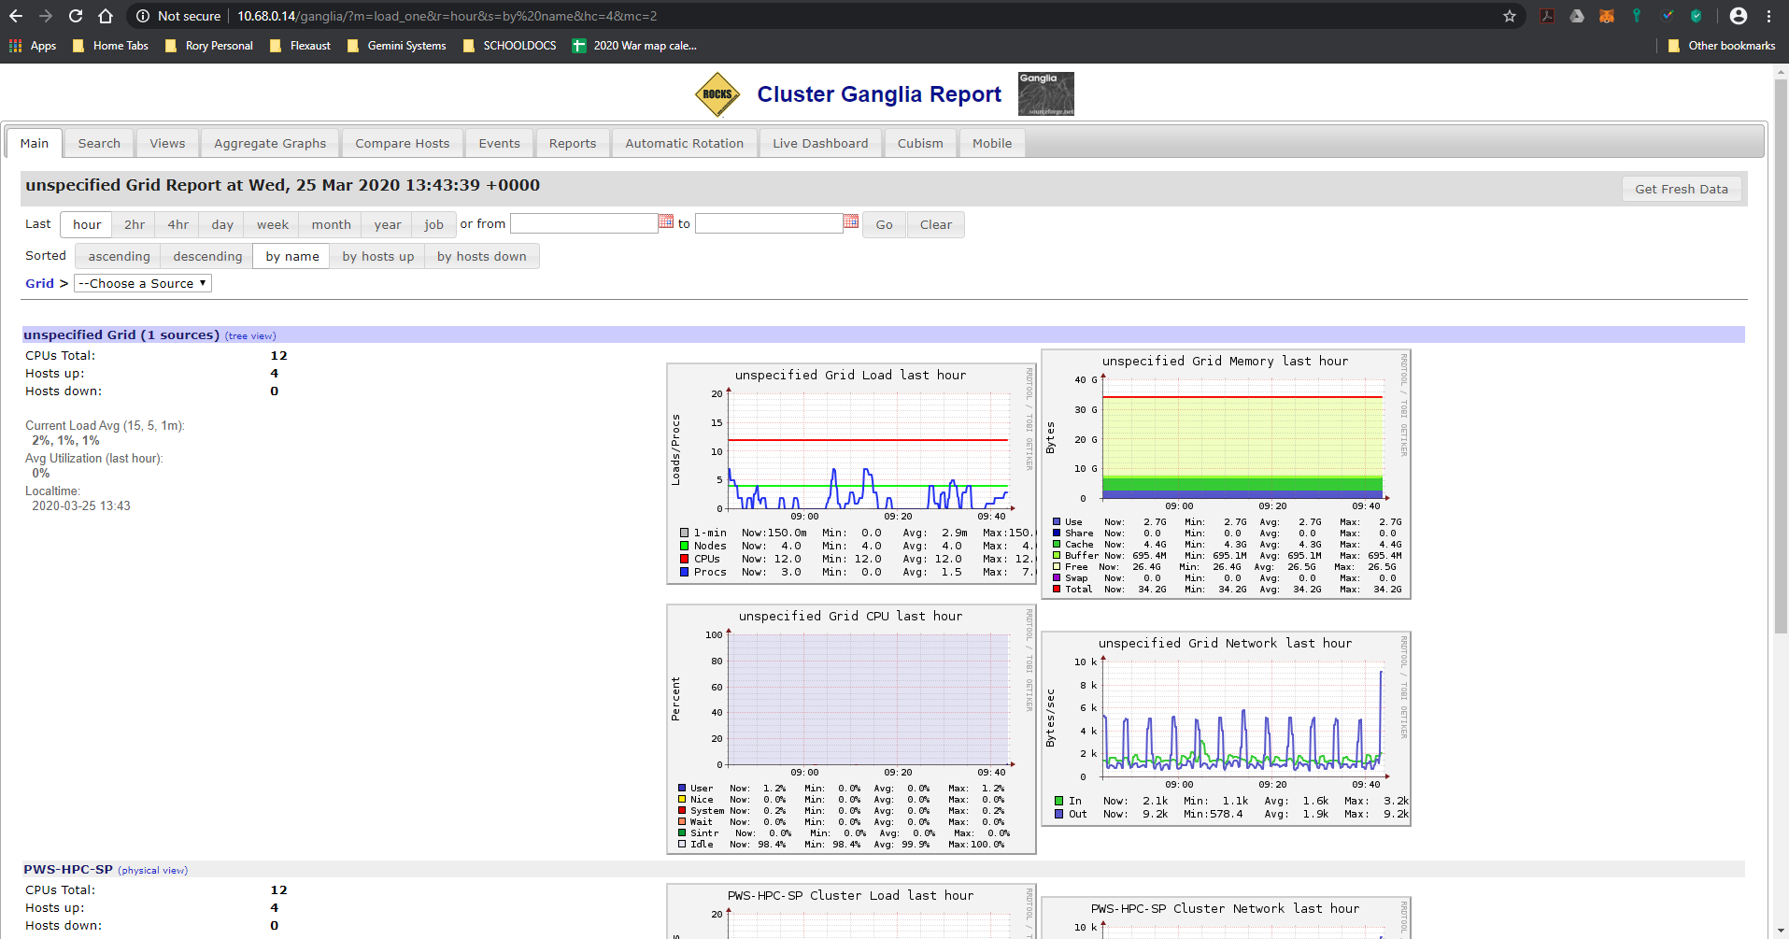

## Programming Pi Calculation

1. Login as the Root user
2. Open a CLI terminal
3. Type “adduser username”
   1. Type passwd username
   2. Then enter a password for the new user.
4. Copy <https://files.pythonhosted.org/packages/ca/63/3384ebb3b51af9610086b23ea976e6d27d6d97bf140a76a365bd77a3eb32/mpmath-1.1.0.tar.gz> to the download folder.
5. Unzip tar.gz file into /export/rocks/install/contrib/7.0/arch/RPMS
6. Create a new XML configuration file that will extend the current compute.xml configuration file:
   1. # cd /export/rocks/install/site-profiles/7.0/nodes
   2. # cp skeleton.xml extend-compute.xml
7. Type nano extend-compute.xml
   1. Inside extend-compute.xml, add the package name by changing the section from:
      1. <package> <!-- insert your package name here --> </package>
      2. <package> mpmath-1.1.0 </package>
      3. Press
8. Now build a new Rocks distribution. This will bind the new package into a RedHat compatible distribution in the directory /export/rocks/install/rocks-dist/....
   1. # cd /export/rocks/install
   2. # rocks create distro
9. Type nano pi.py
   1. Inside the text editor write out the pi calculation program.

#!/usr/bin/env python

import sys

from time import time

from mpmath import mp

digits = int(sys.argv[1])

mp.dps = digits

print("Pi is approximately equal to:")

start_time = time()

print(mp.pi)

end_time = time()

seconds = end_time - start_time

print("Done, {} digits in {} seconds".format(digits,seconds))

* 1. Press ctrl+o to save the file
  2. Press ctrl+x to exit

1. At the command prompt type python pi.py 1000

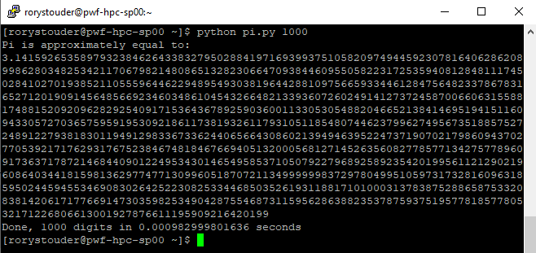

1. You can add up to 10 zeros behind the 1. And con-cat the results to a text file with the command
2. Python pi.py 1000 | vi pi.txt

# VIII. Conclusion

## 

The process of researching, and building the High Performance Compute Cluster was the most fun part, I highly suggest that anyone with the slightest interest in building a clustered computer should take the time to try this themselves. I found that the customization of the ROCKS CentOS 7.0 linux distribution was difficult to understand, and harder to implement for someone who has limited exposure to linux kernel customizations. I struggled with this portion but after much research and trial and error, I believe my senior project is a success.

# IX. References

* 1. Building a Rocks High Performance Cluster with CentOS 6.5 <https://www.youtube.com/watch?v=BQil0smjbX8>
  2. ROCKS cluster Wiki <https://github.com/rocksclusters/wiki/wiki>
  3. Setting up a ROCKS cluster in Oracle VM <https://github.com/rocksclusters/wiki/wiki/howtos-rocks-virtualbox>
  4. The ROCKS User guide <http://central-7-0-x86-64.rocksclusters.org/roll-documentation/base/7.0/>
  5. Python program for calculating Pi <https://www.vanderbilt.edu/accre/getting-started/tutorial/>
  6. Mpmath Python package install <http://mpmath.org/doc/current/setup.html>

# 

# X. Appendices

## Project Status Reports.

**Project Status Report**

**High Performance Computing Cluster**

**Rory Stouder**

**Week Ending: 01/26/2020**

**Project Status Summary**  Percent Complete: 10%

|  |  |  |  |  |
| --- | --- | --- | --- | --- |
| Scope | Schedule | Cost | Risks | Quality |

The project schedule is On-Schedule at 10% complete, as all the project planning and hardware procurement went very smoothly. After switching to a project for myself, I discussed the project parameters with my current employer, and they have generously offered to donate several computers slated for recycling to the HPC cluster build.

**Work Completed Last Week**

I was able to research and procure the equipment needed to build a High Performance Cluster, including the wood to build a frame with wheeled castors, to move the very heavy computer around. I have downloaded all software, and installed a Virtual Computer Manager on a test computer.

**Work Planned For Next Week**

I will be installing and testing in a virtual environment the cluster computer configuration, for two different Linux OS distributions. These will be CentOS and Ubuntu, to test the ease of setting up and running a virtual HPC and managing a LAN Gaming server.

**Open Issues**

I could not get CentOS to boot from the installation media USB, to install on the master node. CentOS is the prefered method of running a Cluster computer, but not the only option so I will also be testing a Ubuntu Server version of clustering.

**Closed Issues**

I am now working on my own project, closing the issue of miscommunication and lack of motivation to continue to work in a group setting.

**Open Risks**

Without being able to boot the CentOS cluster software on the master-node the prefered method with more wiki-knowledge available online will not work. without the CentOS functioning will have to try to use Ubuntu to complete a HPC and show benchmarking speed tests.

**Deliverables and Milestones**

|  |  |  |  |  |  |
| --- | --- | --- | --- | --- | --- |
| Milestone | Planned | Forecasted | Actual | Status | Hours To Date |
| Project plan | 01/23/20 | 01/23/20 | 01/23/20 | Completed | 3 |
| Project Hardware and software | 01/26/20 | 01/26/20 | 01/25/20 | Completed | 6 |
| Proof of concept in Virtual | 02/06/20 | 02/06/20 |  | On Schedule | 1 |
| HPC Cluster build and test | 02/23/20 | 02/23/20 |  | On Schedule | 3 |
| HPC Cluster Production Run | 03/18/20 | 03/18/20 |  | On Schedule | 0 |
|  |  |  |  |  |  |
| Deliverable | Planned | Forecasted | Actual | Status | Hours To Date |
| HPC Virtual Environment | 02/06/20 | 02/06/20 |  |  | .5 days |
| HPC Cluster Build | 02/23/20 | 02/23/20 |  | On Schedule | 0 days |
| Documentation | 3/18/20 | 3/18/20 |  | On Schedule | 0 days |
| Project Binder | 4/16/20 | 4/16/20 |  | On Schedule | 0 days |
| Senior Poster Day Presentation | 4/21/20 | 4/21/20 |  | On Schedule | 0 days |
|  |  |  |  |  |  |
|  |  |  |  |  |  |

**Project Schedule**

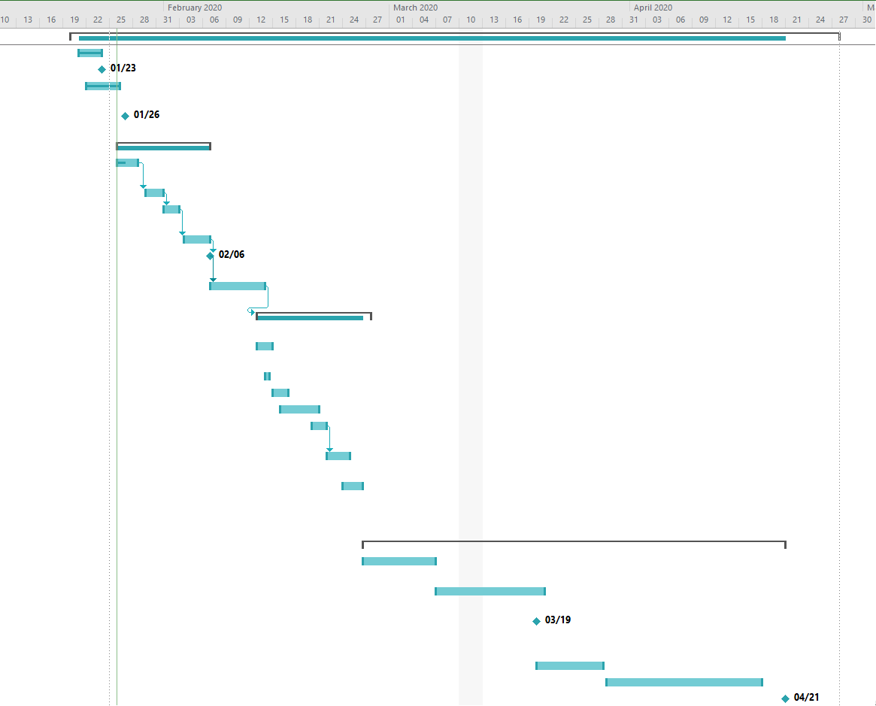

**Project Status Report**

**High Performance Computing Cluster**

**Rory Stouder**

**Week Ending: 02/02/2020**

**Project Status Summary**  Percent Complete: 19%

|  |  |  |  |  |
| --- | --- | --- | --- | --- |
| Scope | Schedule | Cost | Risks | Quality |

The project schedule is ahead of Schedule at 19% complete, I have completed the virtual clusters, and am currently testing the Ubuntu cluster for viability as a LAN game server, for a multi-player linux game under the GNU license.

**Work Completed Last Week**

I installed the CentOS ROCKS cluster on Oracle VirtualBox on my windows computer at home, I was able to cluster the three virtual machine CentOS instances into one working computer and run a test program to test compute-ability of the test cluster. I also spun up a Ubuntu virtual cluster on my windows computer at home. I have not yet tested the Ubuntu cluster. I was also able to provision the Cisco SG300-58p managed switch with the necessary VLANs to separate traffic from the computer cluster and the Gaming clients connecting to the virtual cluster’s master node/ game server.

**Work Planned For Next Week**

For the next week I will be testing the Ubuntu virtual cluster, and with that I will have proven that it is possible to run a compute cluster utilizing two different Linux OS build kernels. This will allow for a backup installation in the event that the primary doesn’t work by compute cluster delivery date.

**Open Issues**

I could not get CentOS to boot from the installation media USB, to install on the master node. CentOS is the prefered method of running a Cluster computer. I have not yet tried again, with a different master node.

The open issue right now is getting the Ubuntu virtual cluster to communicate with each node in the cluster, and utilizing the correct virtual LAN settings to accomplish this. After this I will be able to test the cluster and install the gaming server.

**Closed Issues**

After consulting a Network engineer I was able to successfully provision the Cisco switch with the necessary VLANs to separate traffic and secure the compute cluster.

**Open Risks**

Without being able to boot the CentOS cluster software on the master-node the prefered method with more wiki-knowledge available online will not work. without the CentOS functioning will have to try to use Ubuntu to complete a HPC and show benchmarking speed tests.

Being only one member in this group, if I get sick or injured, there is nobody else to fall back on to pick up the slack.

**Deliverables and Milestones**

|  |  |  |  |  |  |
| --- | --- | --- | --- | --- | --- |
| Milestone | Planned | Forecasted | Actual | Status | Hours To Date |
| Project plan | 01/23/20 | 01/23/20 | 01/23/20 | Completed | 3 |
| Project Hardware and software | 01/26/20 | 01/26/20 | 01/25/20 | Completed | 6 |
| Proof of concept in Virtual | 02/06/20 | 02/06/20 |  | On Schedule | 5 |
| HPC Cluster build and test | 02/23/20 | 02/23/20 |  | On Schedule | 3 |
| HPC Cluster Production Run | 03/18/20 | 03/18/20 |  | On Schedule | 0 |
|  |  |  |  |  |  |
| Deliverable | Planned | Forecasted | Actual | Status | Hours To Date |
| HPC Virtual Environment | 02/06/20 | 02/06/20 |  | On Schedule | 3 days |
| HPC Cluster Build | 02/23/20 | 02/23/20 |  | On Schedule | 0 days |
| Documentation | 3/18/20 | 3/18/20 |  | On Schedule | 0 days |
| Project Binder | 4/16/20 | 4/16/20 |  | On Schedule | 0 days |
| Senior Poster Day Presentation | 4/21/20 | 4/21/20 |  | On Schedule | 0 days |
|  |  |  |  |  |  |
|  |  |  |  |  |  |

**Project Schedule**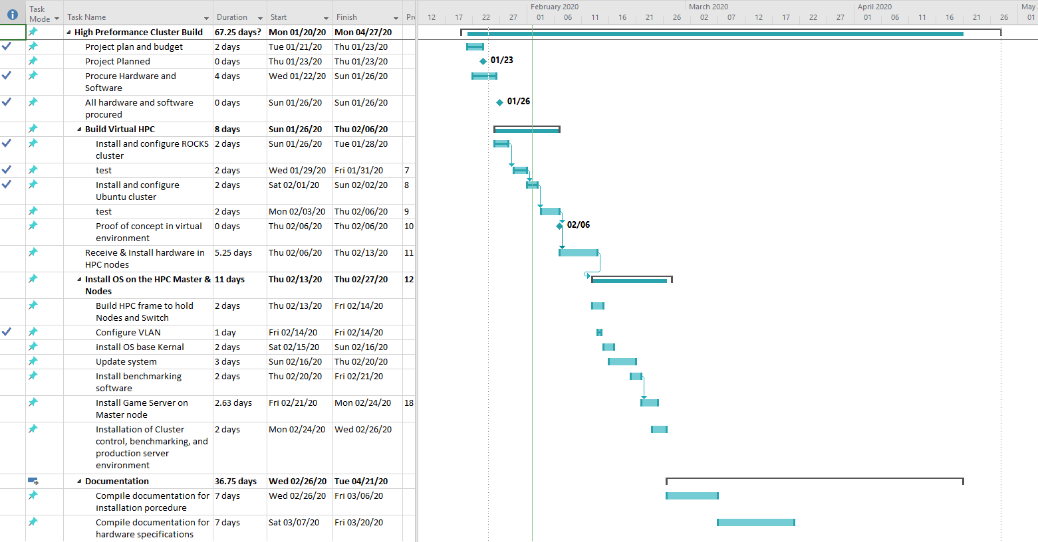

**Project Status Report**

**High Performance Computing Cluster**

**Rory Stouder**

**Week Ending: 02/09/2020**

**Project Status Summary**  Percent Complete: 33%

|  |  |  |  |  |
| --- | --- | --- | --- | --- |
| Scope | Schedule | Cost | Risks | Quality |

The project schedule is ahead of Schedule at 33% complete, I have completed the virtual cluster testing, and have moved into the OS kernel install. I have installed Ubuntu on five computers, four of which are part of the HPC cluster.

**Work Completed Last Week**

I finished testing the virtual environment, and have moved into installing the OS kernel on the hardware. I have installed Ubuntu desktop on the master-node and Ubuntu server on the 3 compute-support-nodes. I have followed the tutorial from the Ubuntu wiki, and am currently working on getting the RSA public / private key to pass between machines.

**Work Planned For Next Week**

Next week I will get the RSA key pass to function properly, so that I can run my test program that displays the CPU used to print the hello world message. Once I have that functioning I will then install the game server in the home directory of the Superuser of the HPS cluster.

**Open Issues**

I could not get CentOS to boot from the installation media USB, to install on the master node. CentOS is the prefered method of running a Cluster computer. I have not yet tried again, with a different master node.

The open issue right now is getting the Ubuntu cluster to communicate across nodes with the RSA public key pass functioning. then running the test compile program.

**Closed Issues**

After consulting a Network engineer I was able to successfully provision the Cisco switch with the necessary VLANs to separate traffic and secure the compute cluster.

Virtual test environment functions properly.

**Open Risks**

Without being able to boot the CentOS cluster software on the master-node the prefered method with more wiki-knowledge available online will not work. without the CentOS functioning will have to try to use Ubuntu to complete a HPC and show benchmarking speed tests.

minimal time frame to get the Ubuntu cluster to function, before having to scrap and try the CentOS ROCKS cluster install, which installed virtually with ease.

Being only one member in this group, if I get sick or injured, there is nobody else to fall back on to pick up the slack.

Seasonal Depression, leading to procrastination.

**Deliverables and Milestones**

|  |  |  |  |  |  |
| --- | --- | --- | --- | --- | --- |
| Milestone | Planned | Forecasted | Actual | Status | Hours To Date |
| Project plan | 01/23/20 | 01/23/20 | 01/23/20 | Completed | 3 |
| Project Hardware and software | 01/26/20 | 01/26/20 | 01/25/20 | Completed | 6 |
| Proof of concept in Virtual | 02/06/20 | 02/06/20 | 01/28.20 | Completed | 10 |
| HPC Cluster build and test | 02/23/20 | 02/23/20 |  | On Schedule | 16 |
| HPC Cluster Production Run | 03/18/20 | 03/18/20 |  | On Schedule | 0 |
|  |  |  |  |  |  |
| Deliverable | Planned | Forecasted | Actual | Status | Hours To Date |
| HPC Virtual Environment | 02/06/20 | 02/06/20 | 01/28/20 | Completed | 4 days |
| HPC Cluster Build | 02/23/20 | 02/23/20 |  | On Schedule | 2 days |
| Documentation | 3/18/20 | 3/18/20 |  | On Schedule | 0 days |
| Project Binder | 4/16/20 | 4/16/20 |  | On Schedule | 0 days |
| Senior Poster Day Presentation | 4/21/20 | 4/21/20 |  | On Schedule | 0 days |
|  |  |  |  |  |  |
|  |  |  |  |  |  |

**Project Schedule**

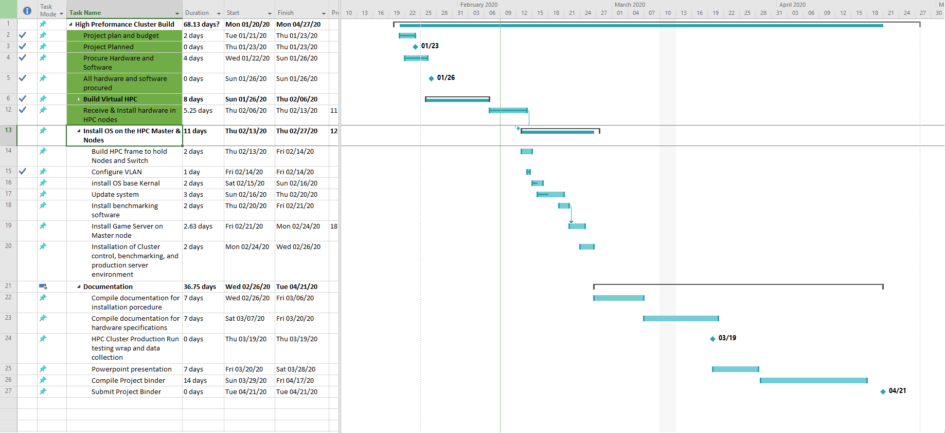

# 

**Project Status Report**

**High Performance Computing Cluster**

**Rory Stouder**

**Week Ending: 02/16/2020**

**Project Status Summary**  Percent Complete: 40%

|  |  |  |  |  |
| --- | --- | --- | --- | --- |
| Scope | Schedule | Cost | Risks | Quality |

The project schedule is slightly behind Schedule at 40% complete, I have completed the installation of the Master-node for the HPC cluster. I fell behind because of personal issues with my loved ones. In the long run of my life they will matter more to me than any school project which may or may not get me a job. I was unable to get the Ubuntu Beowulf cluster to function.

I am very happy to know that the Master-node is properly functioning as a DNS/DHCP server as well as routing traffic from the public network to the private Cluster LAN. This emboldens me to dive deeper into networking and design.

**Work Completed Last Week**

I installed the Master-node base kernel and all required packages to run an effective HPC cluster on CentOS 7.0 with Rocks cluster Anaconda. As I was reading the instructions, it suggested that I set up a local webserver to host the server rolls and ISO files needed to install the OS on each computer. I worked all week on trying to install and get the local Rolls server to function because the http address that was default with the installation medium, didn’t point to a mirror that hosted all the server rolls. After following along with the instructions I noticed that there was a www. address that you were to test your output against. Once entering that www address, the server starts installing like clockwork. I am currently working on the installation of the first computer-node in the cluster.

**Work Planned For Next Week**

I will build the computer frame so that I can transport this computer to the senior project day. without breaking my back.

**Open Issues**

Installing the game server on the master node, the instructions are not as clear cut as on ubuntu. I may end up installing a virtual server on the cluster and create one massive computer install Ubuntu on it so that I can easily install the game server on the Cluster.

**Closed Issues**

I was able to get the CentOS kernel to boot, I was able to point the installation towards the correct web server that hosted the server rolls. and install my first Master-node.

**Open Risks**

Asked to stay over at work and reduce my time to work on my project and other school work.

Having to return work computers.

Being only one member in this group, if I get sick or injured, there is nobody else to fall back on to pick up the slack.

Seasonal Depression, leading to procrastination.

**Deliverables and Milestones**

|  |  |  |  |  |  |
| --- | --- | --- | --- | --- | --- |
| Milestone | Planned | Forecasted | Actual | Status | Hours To Date |
| Project plan | 01/23/20 | 01/23/20 | 01/23/20 | Completed | 3 |
| Project Hardware and software | 01/26/20 | 01/26/20 | 01/25/20 | Completed | 6 |
| Proof of concept in Virtual | 02/06/20 | 02/06/20 | 01/28.20 | Completed | 10 |
| HPC Cluster build and test | 02/23/20 | 02/23/20 |  | On Schedule | 32 |
| HPC Cluster Production Run | 03/18/20 | 03/18/20 |  | On Schedule | 0 |
|  |  |  |  |  |  |
| Deliverable | Planned | Forecasted | Actual | Status | Hours To Date |
| HPC Virtual Environment | 02/06/20 | 02/06/20 | 01/28/20 | Completed | 4 days |
| HPC Cluster Build | 02/23/20 | 02/23/20 |  | Behind | 6 days |
| Documentation | 3/18/20 | 3/18/20 |  | On Schedule | 0 days |
| Project Binder | 4/16/20 | 4/16/20 |  | On Schedule | 0 days |
| Senior Poster Day Presentation | 4/21/20 | 4/21/20 |  | On Schedule | 0 days |
|  |  |  |  |  |  |
|  |  |  |  |  |  |

**Project Schedule**

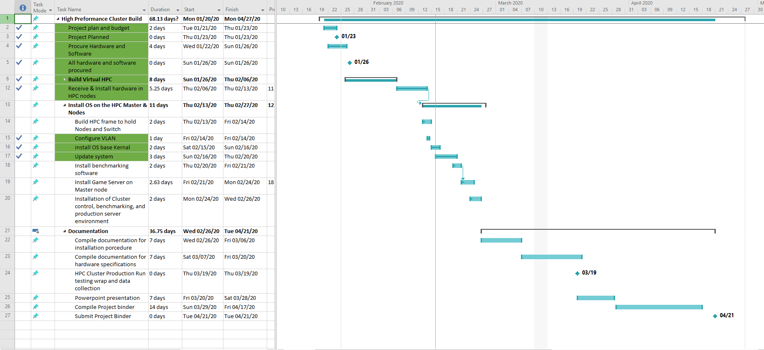

**Project Status Report**

**High Performance Computing Cluster**

**Rory Stouder**

**Week Ending: 02/23/2020**

**Project Status Summary**  Percent Complete: 57%

|  |  |  |  |  |
| --- | --- | --- | --- | --- |
| Scope | Schedule | Cost | Risks | Quality |

The project schedule is slightly behind Schedule at 57% complete, I was able to install the ROCKS cluster on all computers in the cluster. It took two attempts to install, I ended up having to reinstall the master-node with all of the available “rolls” installed, it was able to PXE boot and install all of the compute nodes. This process is quite straightforward, once it all works, the compute nodes auto install from an image on the master-node.

I am very happy that I was able to reinstall the node within just two hours, where if my internet connection was faster it would have been just 30 minutes.

I am disappointed to find out that the High-Performance Compute Cluster doesn’t function as one big desktop computer, and I won’t be able to install the LAN Game server on it as I had hoped. The process to add programs to the ROCKS cluster is a difficult process and each time I have attempted it I have had to reinstall the entire cluster. with the time constraints I admit defeat and will attempt to run a mathematical problem to test the compute cluster’s function.

**Work Completed Last Week**

I installed the Master-node base kernel and all required packages to run an effective HPC cluster on CentOS 7.0 with Rocks cluster Anaconda. with all compute nodes auto-installed. I have installed a resource monitor called Ganglia that allows web access to view current workloads on each node and CPU, for the last hour-week. I have tested that I can power down and boot back up the cluster for transport to project day.

I started to compile the documentation needed to write the manual and other documents required in the project binder.

I have built the frame to hold all the computers, with castors.

**Work Planned For Next Week**

compile and write documentation for the project binder, and find a mathematical problem to calculate on the compute cluster to show functionality.

**Open Issues**

Finding a mathematical problem to test the functionality of the compute cluster.

**Closed Issues**

Game server is a no-go moving on to a different test of the functionality of the compute cluster.

**Open Risks**

Computer parts failing.

Having to return work computers.

Being only one member in this group, if I get sick or injured, there is nobody else to fall back on to pick up the slack.

Seasonal Depression, leading to procrastination.

**Deliverables and Milestones**

|  |  |  |  |  |  |
| --- | --- | --- | --- | --- | --- |
| Milestone | Planned | Forecasted | Actual | Status | Hours To Date |
| Project plan | 01/23/20 | 01/23/20 | 01/23/20 | Completed | 3 |
| Project Hardware and software | 01/26/20 | 01/26/20 | 01/25/20 | Completed | 6 |
| Proof of concept in Virtual | 02/06/20 | 02/06/20 | 01/28.20 | Completed | 10 |
| HPC Cluster build and test | 02/23/20 | 02/23/20 | 02/19/20 | Completed | 48 |
| HPC Cluster Production Run | 03/18/20 | 03/18/20 |  | On Schedule | 0 |
|  |  |  |  |  |  |
| Deliverable | Planned | Forecasted | Actual | Status | Hours To Date |
| HPC Virtual Environment | 02/06/20 | 02/06/20 | 01/28/20 | Completed | 4 days |
| HPC Cluster Build | 02/23/20 | 02/23/20 | 02/19/20 | Completed | 8 days |
| Documentation | 3/18/20 | 3/18/20 |  | On Schedule | 0 days |
| Project Binder | 4/16/20 | 4/16/20 |  | On Schedule | 0 days |
| Senior Poster Day Presentation | 4/21/20 | 4/21/20 |  | On Schedule | 0 days |
|  |  |  |  |  |  |
|  |  |  |  |  |  |

**Project Schedule**

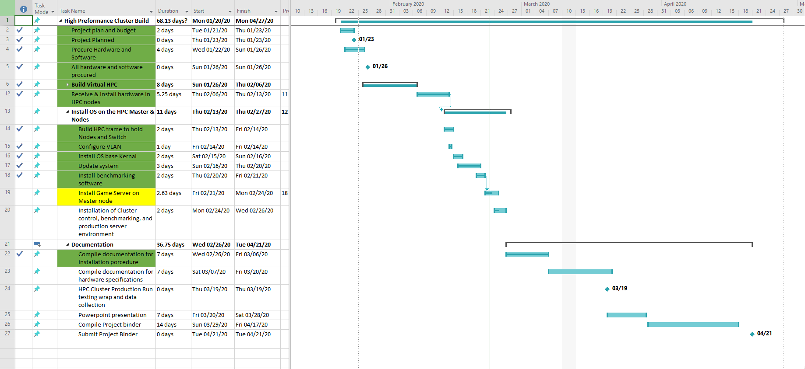

**Project Status Report**

**High Performance Computing Cluster**

**Rory Stouder**

**Week Ending: 03/01/2020**

**Project Status Summary**  Percent Complete: 57%

|  |  |  |  |  |
| --- | --- | --- | --- | --- |
| Scope | Schedule | Cost | Risks | Quality |

The project schedule is slightly behind my schedule at 68% complete. I was able to get a python program to calculate Pi to run. I was able to get the program to calculate Pi and concat it to a txt file upto 1 million decimals places. I so far have only been able to run the python program on one CPU contained within the cluster.

currently working on getting the Bash script to submit the job to the Sun Grid Engine job scheduler, so that it ultimately uses 11 of the 12 CPU’s and all of the RAM.

**Work Completed Last Week**

I programmed in python, and worked on getting a bash shell script to function, allowing me to submit the python program to the Sun Grid Engine job scheduler that tells the program how to parallel process the program to speed calculations.

**Work Planned For Next Week**

compile and write documentation for the project binder. Get the bash shell script to function and submit a job to the scheduler to be able to show functionality of the compute cluster, to be able to compute.

**Open Issues**

Bash shell script and job submission to job schedule to properly utilize all CPUs in the calculation of Pi.

**Closed Issues**

Found a program to calculate Pi.

**Open Risks**

Computer parts failing.

Only two months left to finish Cluster and benchmarking..

**Deliverables and Milestones**

|  |  |  |  |  |  |
| --- | --- | --- | --- | --- | --- |
| Milestone | Planned | Forecasted | Actual | Status | Hours To Date |
| Project plan | 01/23/20 | 01/23/20 | 01/23/20 | Completed | 3 |
| Project Hardware and software | 01/26/20 | 01/26/20 | 01/25/20 | Completed | 6 |
| Proof of concept in Virtual | 02/06/20 | 02/06/20 | 01/28.20 | Completed | 10 |
| HPC Cluster build and test | 02/23/20 | 02/23/20 | 02/19/20 | Completed | 48 |
| HPC Cluster Production Run | 03/18/20 | 03/18/20 |  | On Schedule | 10 |
|  |  |  |  |  |  |
| Deliverable | Planned | Forecasted | Actual | Status | Hours To Date |
| HPC Virtual Environment | 02/06/20 | 02/06/20 | 01/28/20 | Completed | 4 days |
| HPC Cluster Build | 02/23/20 | 02/23/20 | 02/19/20 | Completed | 8 days |
| Documentation | 3/18/20 | 3/18/20 |  | On Schedule | 2 days |
| Project Binder | 4/16/20 | 4/16/20 |  | On Schedule | 0 days |
| Senior Poster Day Presentation | 4/21/20 | 4/21/20 |  | On Schedule | 0 days |
|  |  |  |  |  |  |
|  |  |  |  |  |  |

**Project Schedule**

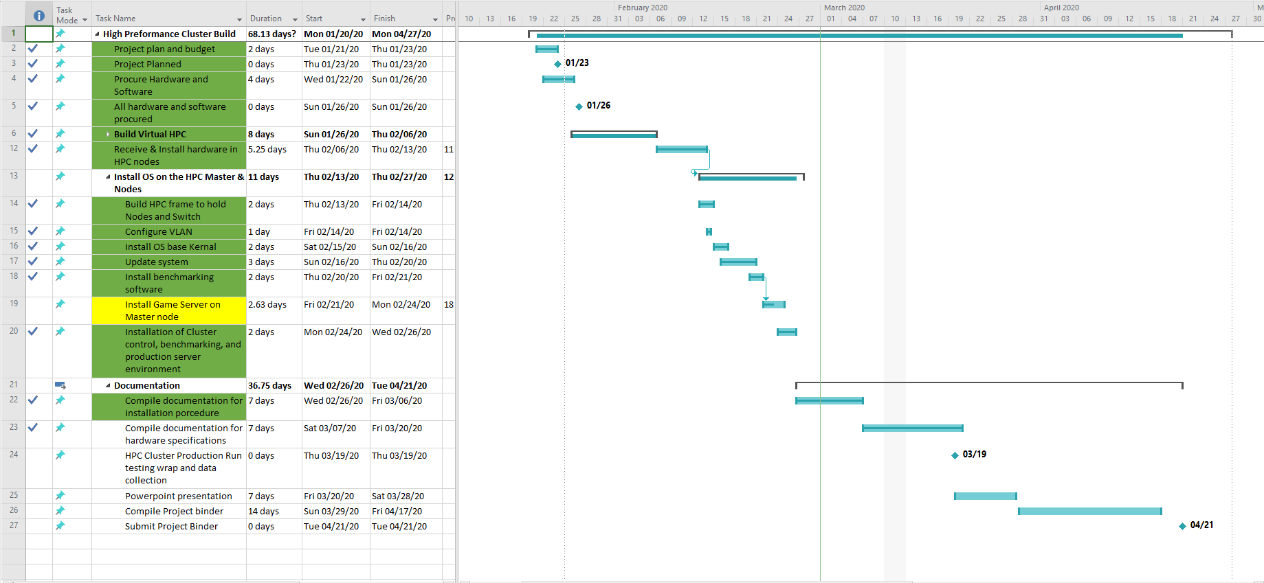

**Project Status Report**

**High Performance Computing Cluster**

**Rory Stouder**

**Week Ending: 03/08/2020**

**Project Status Summary**  Percent Complete: 68%

|  |  |  |  |  |
| --- | --- | --- | --- | --- |
| Scope | Schedule | Cost | Risks | Quality |

The project schedule is slightly behind my schedule at 68% complete. I was able to get a python program to calculate Pi to run. I was able to get the program to calculate Pi and concat it to a txt file upto 1 million decimals places. I so far have only been able to run the python program on one CPU contained within the cluster.

Still working on getting the Bash script to submit the job to the Sun Grid Engine job scheduler, so that it ultimately uses 11 of the 12 CPU’s and all of the RAM. Having trouble with the user permissions

**Work Completed Last Week**

I worked on documentation for the project as this closely aligned with my ENG234 assignment and it was midterms.

**Work Planned For Next Week**

compile and write documentation for the project binder. Get the bash shell script to function and submit a job to the scheduler to be able to show functionality of the compute cluster, to be able to compute.

**Open Issues**

Bash shell script and job submission to job schedule to properly utilize all CPUs in the calculation of Pi.

**Closed Issues**

Found a program to calculate Pi.

**Open Risks**

Computer parts failing.

Only two months left to finish Cluster and benchmarking..

**Deliverables and Milestones**

|  |  |  |  |  |  |
| --- | --- | --- | --- | --- | --- |
| Milestone | Planned | Forecasted | Actual | Status | Hours To Date |
| Project plan | 01/23/20 | 01/23/20 | 01/23/20 | Completed | 3 |
| Project Hardware and software | 01/26/20 | 01/26/20 | 01/25/20 | Completed | 6 |
| Proof of concept in Virtual | 02/06/20 | 02/06/20 | 01/28.20 | Completed | 10 |
| HPC Cluster build and test | 02/23/20 | 02/23/20 | 02/19/20 | Completed | 48 |
| HPC Cluster Production Run | 03/18/20 | 03/18/20 |  | On Schedule | 14 |
|  |  |  |  |  |  |
| Deliverable | Planned | Forecasted | Actual | Status | Hours To Date |
| HPC Virtual Environment | 02/06/20 | 02/06/20 | 01/28/20 | Completed | 4 days |
| HPC Cluster Build | 02/23/20 | 02/23/20 | 02/19/20 | Completed | 8 days |
| Documentation | 3/18/20 | 3/18/20 |  | On Schedule | 4 days |
| Project Binder | 4/16/20 | 4/16/20 |  | On Schedule | 2 days |
| Senior Poster Day Presentation | 4/21/20 | 4/21/20 |  | On Schedule | 0 days |
|  |  |  |  |  |  |
|  |  |  |  |  |  |

**Project Schedule**

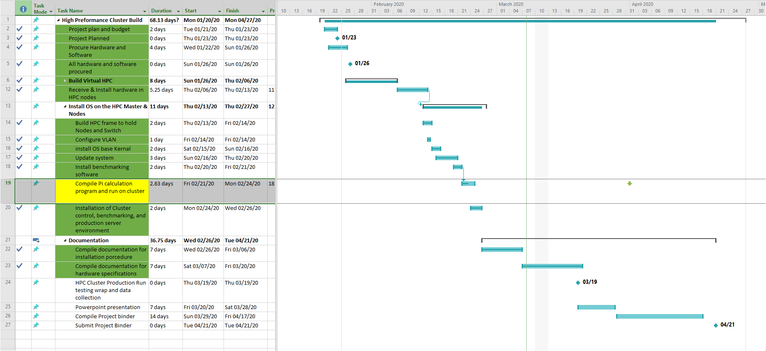

**Project Status Report**

**High Performance Computing Cluster**

**Rory Stouder**

**Week Ending: 03/29/2020**

**Project Status Summary**  Percent Complete: 75%

|  |  |  |  |  |
| --- | --- | --- | --- | --- |
| Scope | Schedule | Cost | Risks | Quality |

The project schedule is slightly behind my schedule at 75% complete. I was able to get a python program to calculate Pi to run. I was able to get the program to calculate Pi and concat it to a txt file upto 1 million decimals places. I so far have only been able to run the python program on one CPU contained within the cluster.

Still working on getting the Bash script to submit the job to the Sun Grid Engine job scheduler, so that it ultimately uses 11 of the 12 CPU’s and all of the RAM. Having trouble with the user permissions. I have scoured the internet and help desks, I have come to the conclusion that I messed up somewhere and didn’t create the user properly, that is to submit jobs. I am not so confused as to what I have done and what should be done. I worry that I won’t get a program to run on the cluster, causing a failing grade.

**Work Completed Last Week**

I worked on documentation for the project as this closely aligned with my ENG234 assignment and it was midterms. I tried to get the Pi calculation to run on more than one CPU but unsuccessfully

**Work Planned For Next Week**

Reinstall the cluster, I am unable to submit any job to the scheduler, and I have been unable to find any help as to how to solve this problem, other than starting from scratch (I may not do this because I could just end up in the same place after spending hours on it.

**Open Issues**

Bash shell script and job submission to job schedule to properly utilize all CPUs in the calculation of Pi.

**Closed Issues**

Found a program to calculate Pi.

**Open Risks**

Computer parts failing.

The pandemic called COVID-19.

**Deliverables and Milestones**

|  |  |  |  |  |  |
| --- | --- | --- | --- | --- | --- |
| Milestone | Planned | Forecasted | Actual | Status | Hours To Date |
| Project plan | 01/23/20 | 01/23/20 | 01/23/20 | Completed | 3 |
| Project Hardware and software | 01/26/20 | 01/26/20 | 01/25/20 | Completed | 6 |
| Proof of concept in Virtual | 02/06/20 | 02/06/20 | 01/28.20 | Completed | 10 |
| HPC Cluster build and test | 02/23/20 | 02/23/20 | 02/19/20 | Completed | 48 |
| HPC Cluster Production Run | 03/18/20 | 03/18/20 |  | behind | 40 |
|  |  |  |  |  |  |
| Deliverable | Planned | Forecasted | Actual | Status | Hours To Date |
| HPC Virtual Environment | 02/06/20 | 02/06/20 | 01/28/20 | Completed | 4 days |
| HPC Cluster Build | 02/23/20 | 02/23/20 | 02/19/20 | Completed | 8 days |
| Documentation | 3/18/20 | 3/18/20 |  | behind | 10 days |
| Project Binder | 4/16/20 | 4/16/20 |  | On Schedule | 8 days |
| Senior Poster Day Presentation | 4/21/20 | 4/21/20 |  | On Schedule | 0 days |
|  |  |  |  |  |  |
|  |  |  |  |  |  |

**Project Schedule**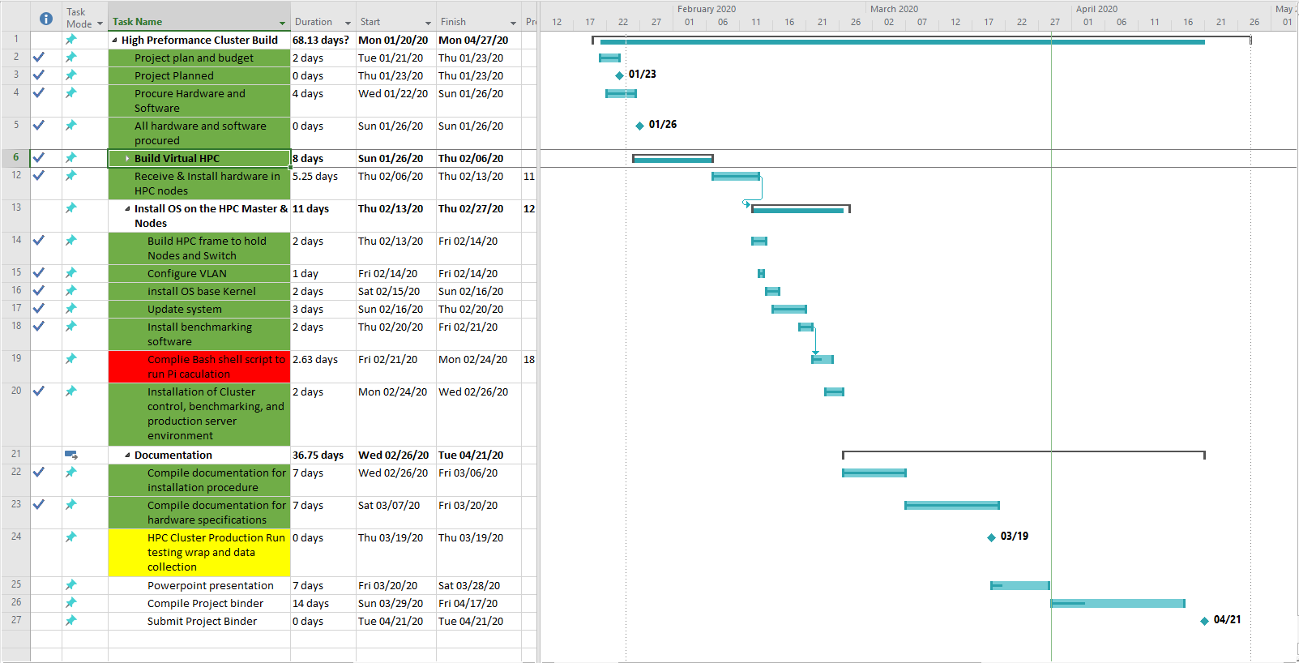

**Project Status Report**

**High Performance Computing Cluster**

**Rory Stouder**

**Week Ending: 04/05/2020**

**Project Status Summary**  Percent Complete: 73%

|  |  |  |  |  |
| --- | --- | --- | --- | --- |
| Scope | Schedule | Cost | Risks | Quality |

The project schedule is slightly behind my schedule at 73% complete. I was able to get a python program to calculate Pi to run. I was able to get the program to calculate Pi and concat it to a txt file upto 1 million decimals places. I so far have only been able to run the python program on one CPU contained within the cluster.

Still working on getting the Bash script to submit the job to the Sun Grid Engine job scheduler, so that it ultimately uses 11 of the 12 CPU’s and all of the RAM. Having trouble with the user permissions. I have scoured the internet and help desks, I have come to the conclusion that I messed up somewhere and didn’t create the user properly, that is to submit jobs. I am not so confused as to what I have done and what should be done. I worry that I won’t get a program to run on the cluster, causing a failing grade.

**Work Completed Last Week**

I worked on documentation for the project as this closely aligned with my ENG234 assignment. I tried to get any shell script to be accepted by the Sun Grid Engine, I was able to remotely shutdown each node. So I know the computers can communicate. I am losing time and I am about to throw in the towel on getting anything to run, I will show how I was able to add packages to the special version of linux.

**Work Planned For Next Week**

gather documentation needed for the project binder

**Open Issues**

Bash shell script and job submission to job schedule to properly utilize all CPUs in the calculation of Pi.

**Closed Issues**

Found a program to calculate Pi.

**Open Risks**

Computer parts failing.

The pandemic called COVID-19.

**Deliverables and Milestones**

|  |  |  |  |  |  |
| --- | --- | --- | --- | --- | --- |
| Milestone | Planned | Forecasted | Actual | Status | Hours To Date |
| Project plan | 01/23/20 | 01/23/20 | 01/23/20 | Completed | 3 |
| Project Hardware and software | 01/26/20 | 01/26/20 | 01/25/20 | Completed | 6 |
| Proof of concept in Virtual | 02/06/20 | 02/06/20 | 01/28.20 | Completed | 10 |
| HPC Cluster build and test | 02/23/20 | 02/23/20 | 02/19/20 | Completed | 48 |
| HPC Cluster Production Run | 03/18/20 | 4/27/20 |  | failure | 40 |
|  |  |  |  |  |  |
| Deliverable | Planned | Forecasted | Actual | Status | Hours To Date |
| HPC Virtual Environment | 02/06/20 | 02/06/20 | 01/28/20 | Completed | 4 days |
| HPC Cluster Build | 02/23/20 | 02/23/20 | 02/19/20 | Completed | 8 days |
| Documentation | 3/18/20 | 4/17/20 |  | behind | 10 days |
| Project Binder | 4/16/20 | 4/25/20 |  | On Schedule | 8 days |
| Senior Poster Day Presentation | 4/21/20 | 4/27/20 |  | On Schedule | 0 days |
|  |  |  |  |  |  |
|  |  |  |  |  |  |

**Project Schedule**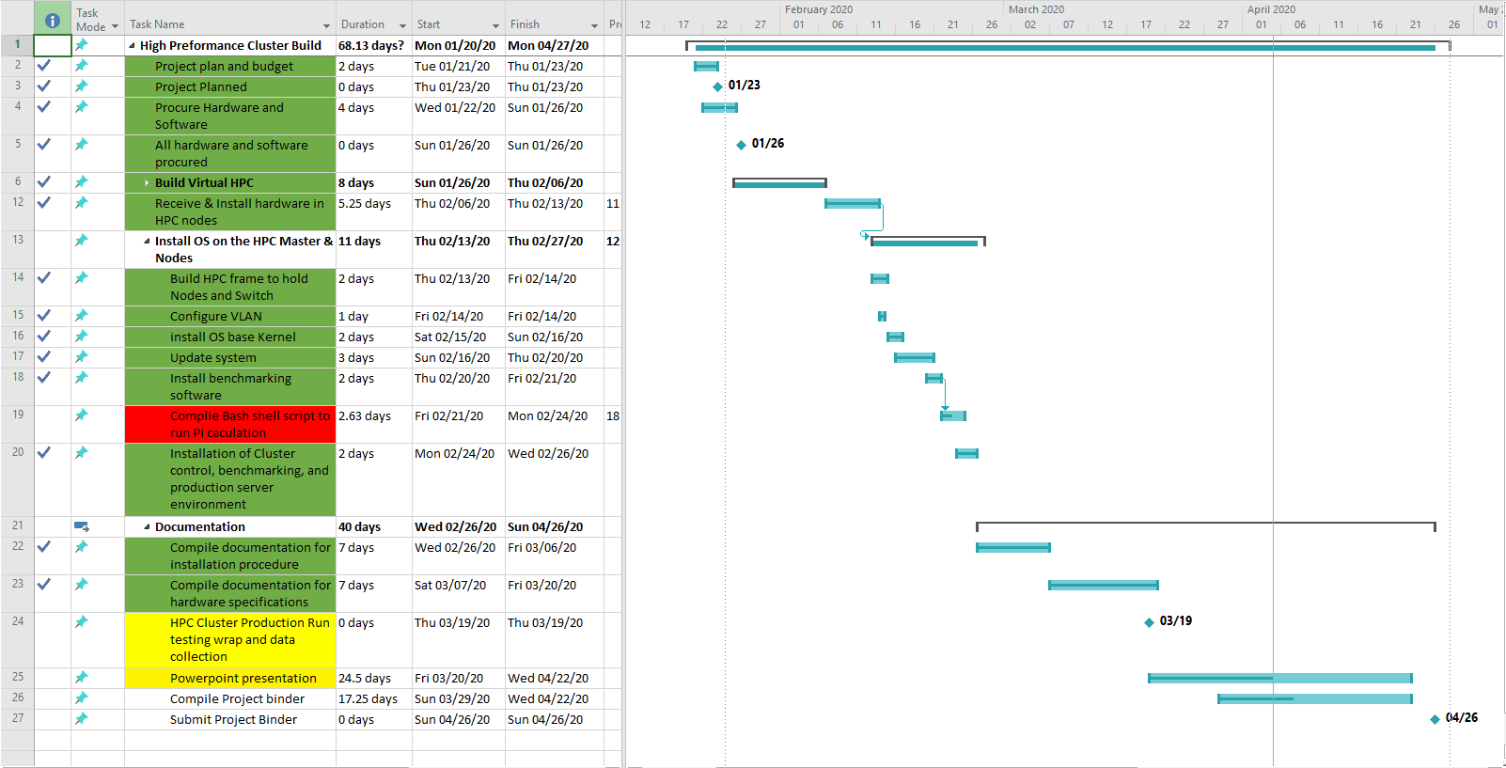

**Project Status Report**

**High Performance Computing Cluster**

**Rory Stouder**

**Week Ending: 04/12/2020**

**Project Status Summary**  Percent Complete: 80%

|  |  |  |  |  |
| --- | --- | --- | --- | --- |
| Scope | Schedule | Cost | Risks | Quality |

The project schedule is slightly behind my schedule at 80% complete. I was able to get a python program to calculate Pi to run. I was able to get the program to calculate Pi and concat it to a txt file upto 1 million decimals places. I so far have only been able to run the python program on one CPU contained within the cluster.

Still working on getting the Bash script to submit the job to the Sun Grid Engine job scheduler, so that it ultimately uses 11 of the 12 CPU’s and all of the RAM. Having trouble with the user permissions. I have scoured the internet and help desks, I have come to the conclusion that I messed up somewhere and didn’t create the user properly, that is to submit jobs. I am not so confused as to what I have done and what should be done. I worry that I won’t get a program to run on the cluster, causing a failing grade.

**Work Completed Last Week**

I compiled the documentation for the binder

**Work Planned For Next Week**

finish project binder, and start on Powerpoint presentation.

**Open Issues**

Bash shell script and job submission to job schedule to properly utilize all CPUs in the calculation of Pi.

**Closed Issues**

Found a program to calculate Pi.

**Open Risks**

Computer parts failing.

The pandemic called COVID-19.

**Deliverables and Milestones**

|  |  |  |  |  |  |
| --- | --- | --- | --- | --- | --- |
| Milestone | Planned | Forecasted | Actual | Status | Hours To Date |
| Project plan | 01/23/20 | 01/23/20 | 01/23/20 | Completed | 3 |
| Project Hardware and software | 01/26/20 | 01/26/20 | 01/25/20 | Completed | 6 |
| Proof of concept in Virtual | 02/06/20 | 02/06/20 | 01/28.20 | Completed | 10 |
| HPC Cluster build and test | 02/23/20 | 02/23/20 | 02/19/20 | Completed | 48 |
| HPC Cluster Production Run | 03/18/20 | 4/27/20 |  | failure | 40 |
|  |  |  |  |  |  |
| Deliverable | Planned | Forecasted | Actual | Status | Hours To Date |
| HPC Virtual Environment | 02/06/20 | 02/06/20 | 01/28/20 | Completed | 4 days |
| HPC Cluster Build | 02/23/20 | 02/23/20 | 02/19/20 | Completed | 8 days |
| Documentation | 3/18/20 | 4/17/20 |  | behind | 10 days |
| Project Binder | 4/16/20 | 4/25/20 |  | On Schedule | 8 days |
| Senior Poster Day Presentation | 4/21/20 | 4/27/20 |  | On Schedule | 2 days |
|  |  |  |  |  |  |
|  |  |  |  |  |  |

**Project Schedule**

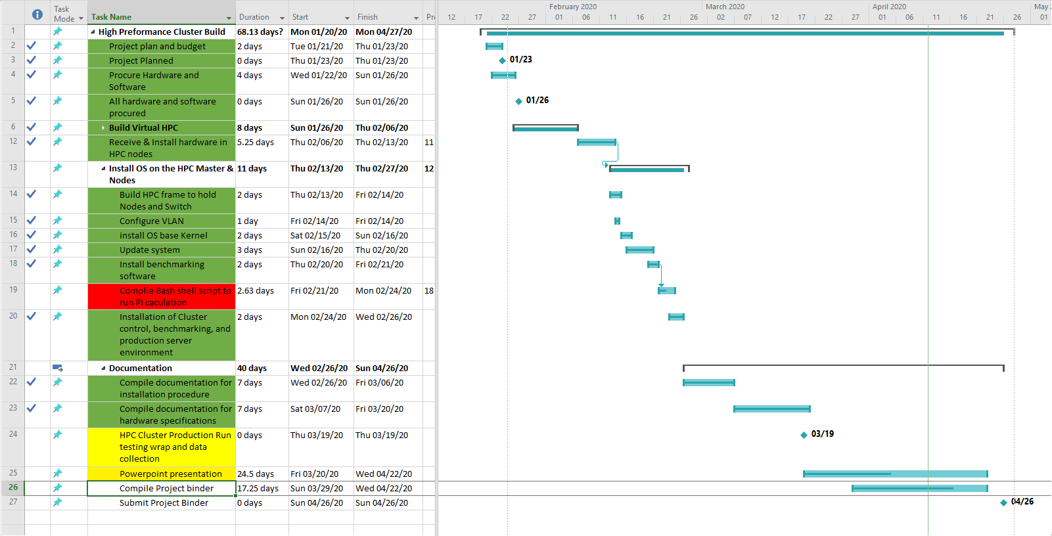

**Project Status Report**

**High Performance Computing Cluster**

**Rory Stouder**

**Week Ending: 04/19/2020**

**Project Status Summary**  Percent Complete: 88%

|  |  |  |  |  |
| --- | --- | --- | --- | --- |
| Scope | Schedule | Cost | Risks | Quality |

The project schedule is on schedule at 88% complete. I was able to get a python program to calculate Pi to run. I was able to get the program to calculate Pi and concat it to a txt file upto 1 million decimals places. I have completed the Use case testing for the technical manual and binder.

**Work Completed Last Week**

I compiled the documentation for the binder. Ran Pi and Use case testing of documentation.

**Work Planned For Next Week**

finish project binder, and Powerpoint presentation.

**Open Issues**

Powerpoint presentation recording

**Closed Issues**

Found a program to calculate Pi.

**Open Risks**

The pandemic called COVID-19.

**Deliverables and Milestones**

|  |  |  |  |  |  |
| --- | --- | --- | --- | --- | --- |
| Milestone | Planned | Forecasted | Actual | Status | Hours To Date |
| Project plan | 01/23/20 | 01/23/20 | 01/23/20 | Completed | 3 |
| Project Hardware and software | 01/26/20 | 01/26/20 | 01/25/20 | Completed | 6 |
| Proof of concept in Virtual | 02/06/20 | 02/06/20 | 01/28.20 | Completed | 10 |
| HPC Cluster build and test | 02/23/20 | 02/23/20 | 02/19/20 | Completed | 48 |
| HPC Cluster Production Run | 03/18/20 | 4/27/20 | 4/19/20 | Completed | 50 |
|  |  |  |  |  |  |
| Deliverable | Planned | Forecasted | Actual | Status | Hours To Date |
| HPC Virtual Environment | 02/06/20 | 02/06/20 | 01/28/20 | Completed | 4 days |
| HPC Cluster Build | 02/23/20 | 02/23/20 | 02/19/20 | Completed | 8 days |
| Documentation | 3/18/20 | 4/22/20 |  | On Schedule | 15 days |
| Project Binder | 4/16/20 | 4/27/20 |  | On Schedule | 12 days |
| Senior Poster Day Presentation | 4/21/20 | 5/2/20 |  | On Schedule | 4 days |
|  |  |  |  |  |  |
|  |  |  |  |  |  |

**Project Schedule**

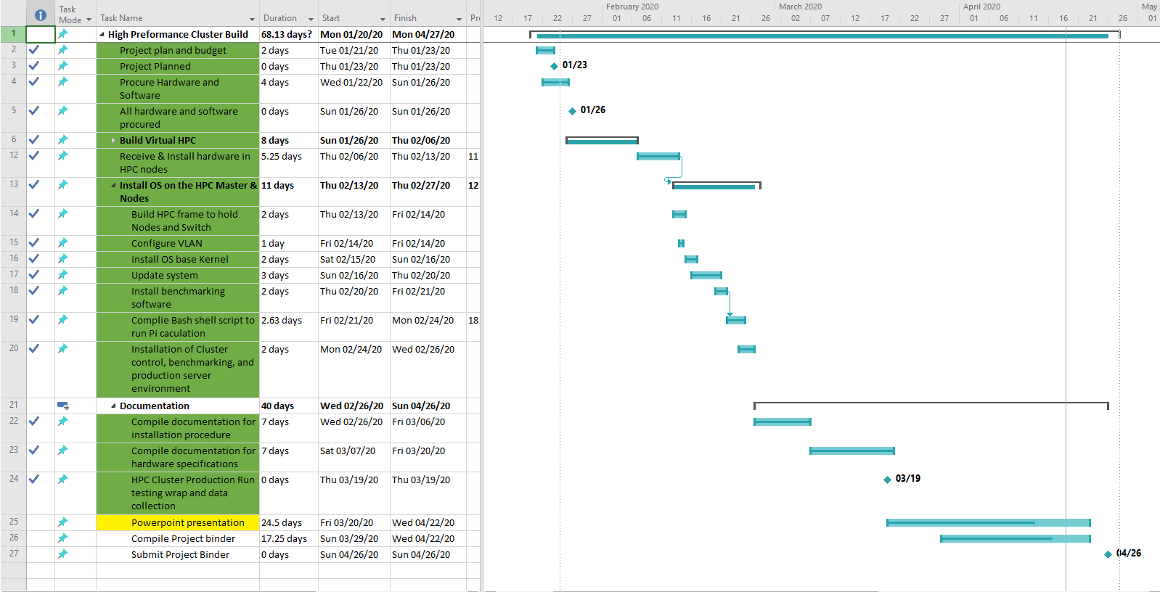

**Project Status Report**

**High Performance Computing Cluster**

**Rory Stouder**

**Week Ending: 04/26/2020**

**Project Status Summary**  Percent Complete: 100%

|  |  |  |  |  |
| --- | --- | --- | --- | --- |
| Scope | Schedule | Cost | Risks | Quality |

The project is complete. I was able to get a python program to calculate Pi to run. I was able to get the program to calculate Pi and concat it to a txt file upto 1 million decimals places. I have completed the Use case testing for the technical manual and binder. I have complied all documentation into the final project binder

**Work Completed Last Week**

I compiled the documentation for the binder. Ran Pi and Use case testing of documentation.

**Work Planned For Next Week**

I plan on recording my presentation

**Open Issues**

# 

**Closed Issues**

**Open Risks**

The pandemic called COVID-19.

**Deliverables and Milestones**

|  |  |  |  |  |  |
| --- | --- | --- | --- | --- | --- |
| Milestone | Planned | Forecasted | Actual | Status | Hours To Date |
| Project plan | 01/23/20 | 01/23/20 | 01/23/20 | Completed | 3 |
| Project Hardware and software | 01/26/20 | 01/26/20 | 01/25/20 | Completed | 6 |
| Proof of concept in Virtual | 02/06/20 | 02/06/20 | 01/28.20 | Completed | 10 |
| HPC Cluster build and test | 02/23/20 | 02/23/20 | 02/19/20 | Completed | 48 |
| HPC Cluster Production Run | 03/18/20 | 4/27/20 | 4/19/20 | Completed | 50 |
|  |  |  |  |  |  |
| Deliverable | Planned | Forecasted | Actual | Status | Hours To Date |
| HPC Virtual Environment | 02/06/20 | 02/06/20 | 01/28/20 | Completed | 4 days |
| HPC Cluster Build | 02/23/20 | 02/23/20 | 02/19/20 | Completed | 8 days |
| Documentation | 3/18/20 | 4/22/20 | 4/26/20 | Completed | 15 days |
| Project Binder | 4/16/20 | 4/27/20 | 4/26/20 | Completed | 14 days |
| Senior Poster Day Presentation | 4/21/20 | 5/2/20 | 4/26/20 | On Schedule | 6 days |
|  |  |  |  |  |  |
|  |  |  |  |  |  |

**Project Schedule**

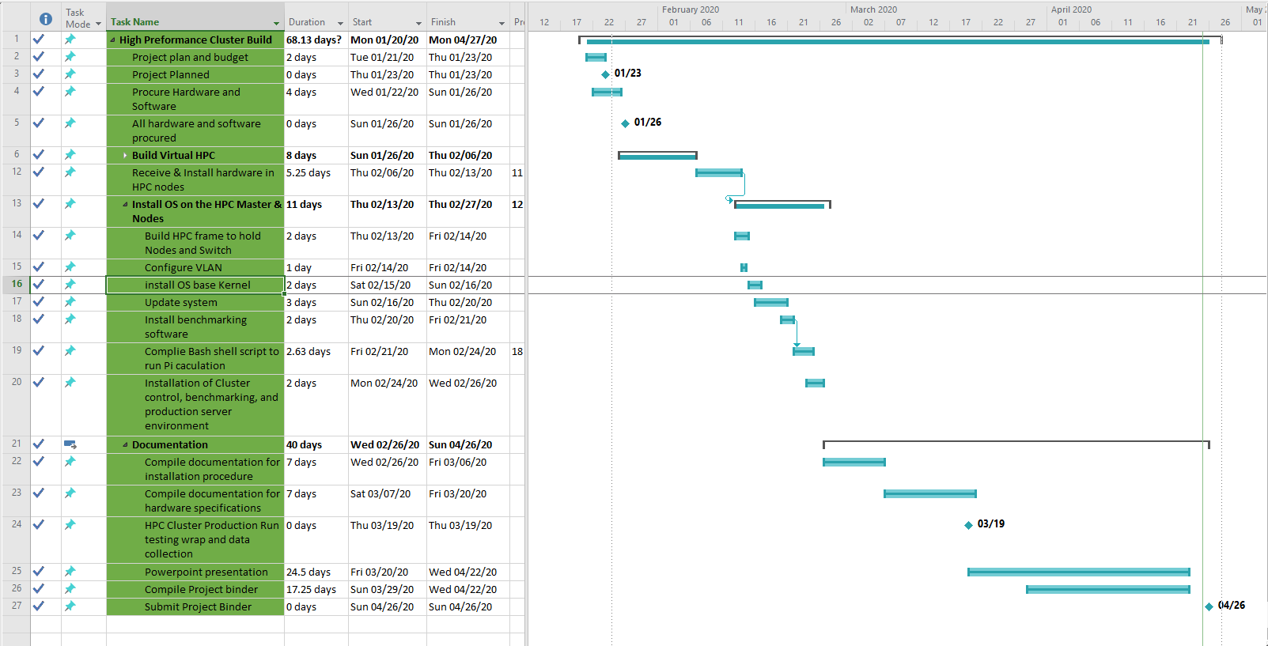

## Project Charter

|  |  |
| --- | --- |
| **Project Name: High Performance Compute Cluster** | **Class: ITC 48100 Spring 2020** |
| **Date: 1/10/20** | **Revision Number: 1** |

|  |  |  |  |  |
| --- | --- | --- | --- | --- |
| Project Goals | | | | |
| *Describe the business need, social need, customer request, technological advancement, opportunity or problem that the project was undertaken to address – i.e., the project justification. Why would someone want to invest in your project?*  The Goal of this project is to construct a cluster computer to calculate Pi out to 10 million decimal digit points. utilizing freely available software and old unused computer hardware. The project will use a custom version of the Linux Operating System Kernel. | | | | |
| Deliverables | | | | |
| *What are the project artifacts? A project artifact is a piece of hardware, software, documents, presentations, etc. Each deliverable should be sufficiently detailed so that the Project Team will understand what needs to be accomplished. Describe the deliverable using action words (verbs) such as “deliver, provide, create, research, etc.*  *Deliverables should be measurable, so the Project Sponsor and Team can determine whether the deliverable has been successfully completed at the project’s conclusion. What needs to be approved for the project to be objectively considered complete?*   1. Research Linux customizations that will facilitate the desired goal. 2. Construct a Virtual environment and test cluster OS 3. Primary Construction of Cluster 4. Pi calculation results | | | | |
| Scope Definition | | | | |
| *Document the scope of work to be delivered. Provide a high level list of ‘what’ needs to be accomplished in order to meet the goals of the project. To assist you in defining scope, use documentation such as RFP’, sales proposals, business requirements, functional specifications, etc. to set and limit the scope.*  *In Scope is what the project will include to meet the requirements of the Project goals.*  *Out of Scope excludes responsibilities, activities, deliverables or other areas that are not part of the Project.*  *The project will include:*   * Four computers functioning as one * VLAN and managed Gigabit switch * A custom python program to calculate Pi * Web portal for resource monitoring   *The project will not include:*   * Electrical engineering * Public web access | | | | |
| Project Milestones | | | | |
| *Identify the significant project milestones, including invoicing dates to the client. As a minimum, each deliverable needs to be identified, along with an estimated date relative to the start of the project. Additionally, some interim milestones of the project's prototype should be identified, such as software flow diagrams, state diagrams, schematics complete, CCA layouts complete, material received, prototypes assembled, testing complete, etc.*   1. VLAN Setup 2. Cluster Frame Built 3. Cluster OS installed 4. Environment Customization for Python calculations. 5. Documentation of installation and testing. | | | | |
| Assumptions, Constraints, and Dependencies | | | | |
| *Identify the assumptions that were made to form the basis of defining scope. Also identify any assumptions that will be made for the purposes of planning the project. The objective here is to set the boundaries and address how the triple project management constraint (scope, time and cost) are potentially impacted/managed.*  *List any constraints (potential factors that will impact the delivery or make it difficult to manage the project) on the project or dependencies on resources or funding to the project. Consider time, cost, dates and regulatory issues as constraints or dependencies to the project.*  *Reference any related documents that were used to define scope and assumptions – e.g., RFQ, RFP, Sales Proposal, etc.*   * Assuming that the virtual environment will function similar to the physical setup * Time Constraints, as I only have one semester to complete * Dependent on anonymous users in wiki-pages for troubleshooting help * Dependent on computer hardware still functioning the entire semester. * Assuming calculation Job submission would be straight forward. | | | | |
| Risks | | | | |
| *Identify the primary risk (negatives) that are perceived that may cause the project to not meet the technical performance requirements (scope of work), the schedule, or the cost (both material and labor)*  **Primary Technical Risk:**  Unable to get CPUs to schedule or share Jobs resources  **Primary Schedule Risk:** Only one semester to plan and execute  **Primary Cost Risk:** Losing my job and support of the company supplying computers. | | | | |
| Budget | | | | |
| *State the proposed/estimated budget for the project and the source of funding (you, your company, a project sponsor, etc.) Estimate the total material ($) and total labor (man-hours) required. No detailed breakdown is necessary.*  **Material Costs (est): $230.00**  **Tool Costs (est): $60.00**  **Labor Hours – Project Team (est): 300**  **Labor Hours – non-Project Team (est): 0** | | | | |
| Project Organizational Structure | | | | |
| *Identify the key stakeholders and team members by name and role.* | | | | |
| **Name** | | **Role** | **Optional Info (email/phone/etc)** | |
| Rory Stouder | | Scrum Master/ Business analysis /  Developer Programmer | [Stourt01@pfw.edu](mailto:Stourt01@pfw.edu) (574)265-6415 | |
|  | |  |  | |
|  | |  |  | |
|  | |  |  | |
|  | |  |  | |
| Project Authorization | | | | |
| **Approved by:** | **Faculty Project Advisor** | | | **Date** |
|  |  | | |  |
| **Approved by:** | **Prof. Michelle Parker** | | | **Date** |
|  |  | | |  |
| **Approved by:** | **Project Manager (you)** | | | **Date** |

## 

## 

## Computer Frame Drawing

